Photo #1. Project site before commencement of work | Photo #2. Site preparation activities in progress | Photo #3. Ground clearing and leveling completed | Photo #4. Initial excavation work completed
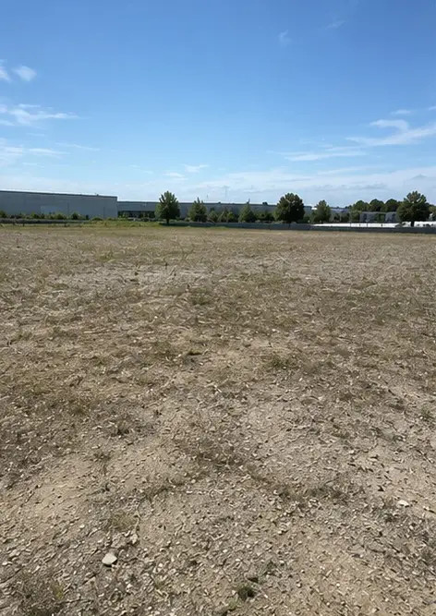 | 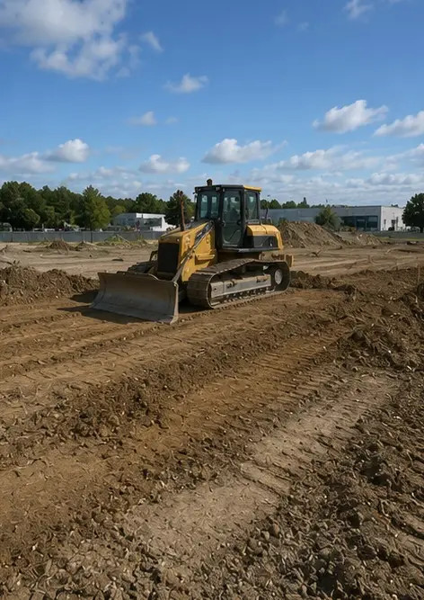 | 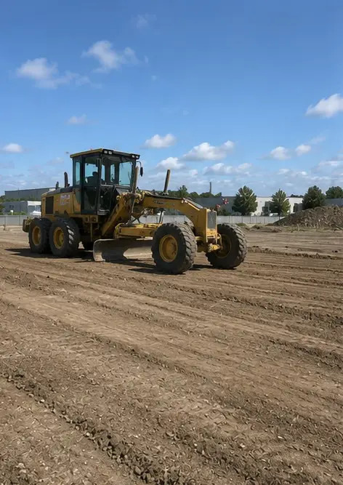 | 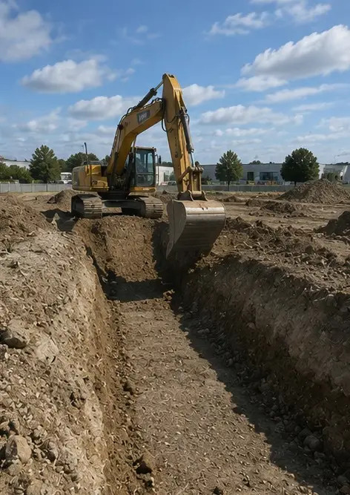
Photo #5. Foundation construction completed | Photo #6. Structural frame assembly started | Photo #7. Structural frame construction in progress | Photo #8. Structural frame completed according to project schedule
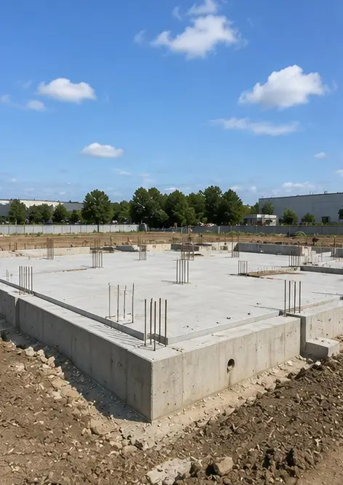 | 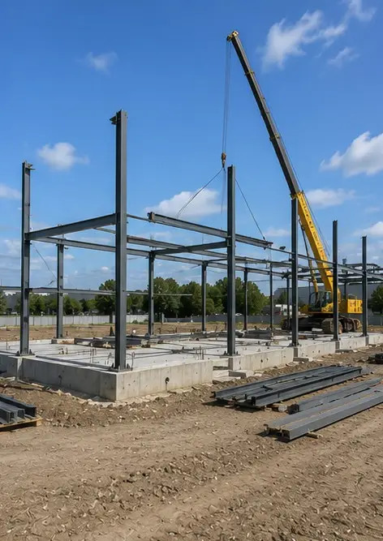 | 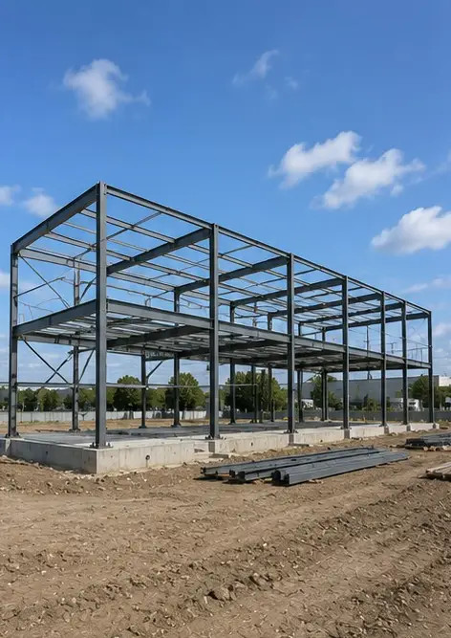 | 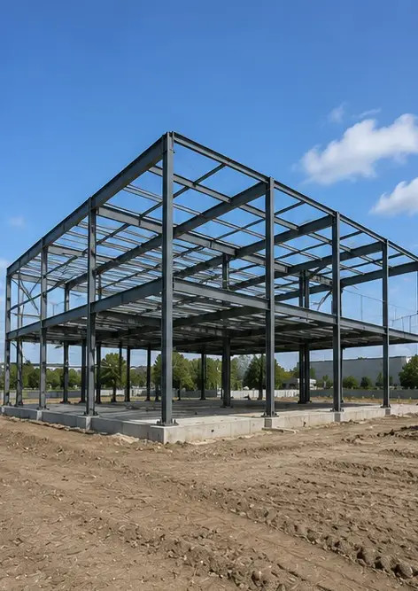
Photo #9. Structural frame completed according to project schedule | Photo #10. Roof construction completed | Photo #11. Electrical systems installation in progress | Photo #12. Plumbing systems installation completed
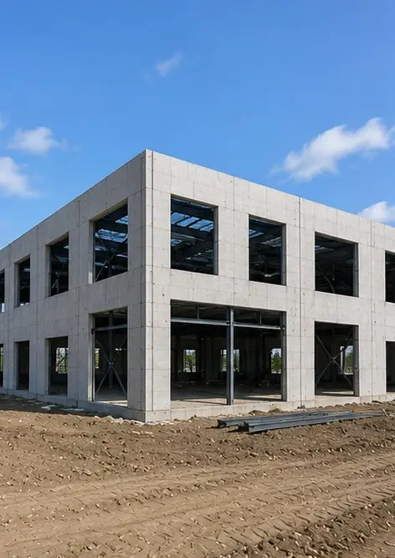 | 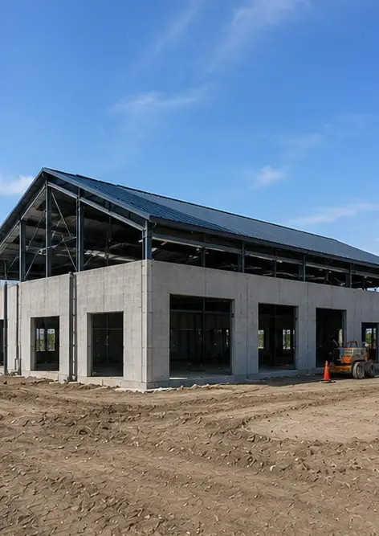 | 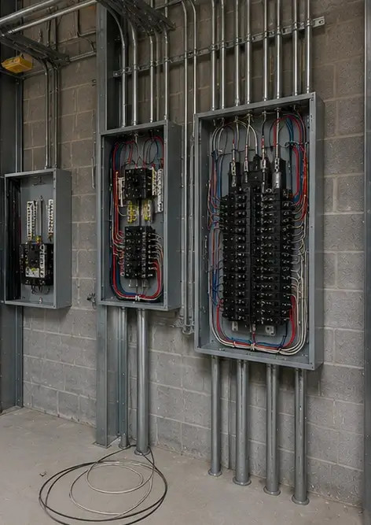 | 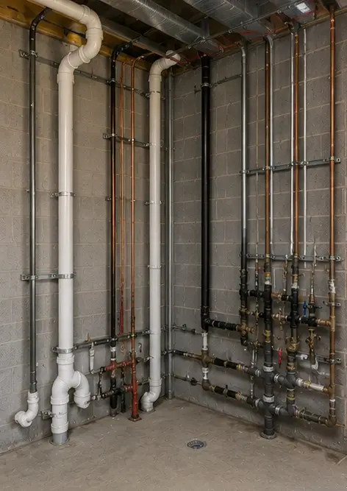
Photo #13. Interior finishing work in progress | Photo #14. Equipment installation completed | Photo #15. Final project inspection conducted | Photo #16. Completed project ready for operation
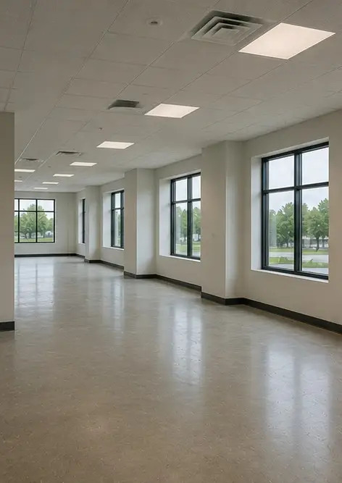 | 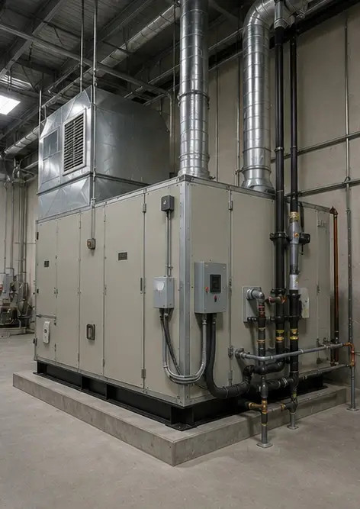 | 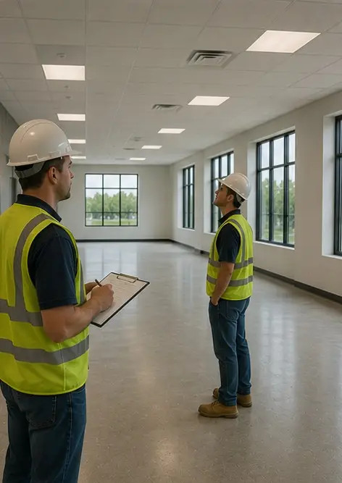 | 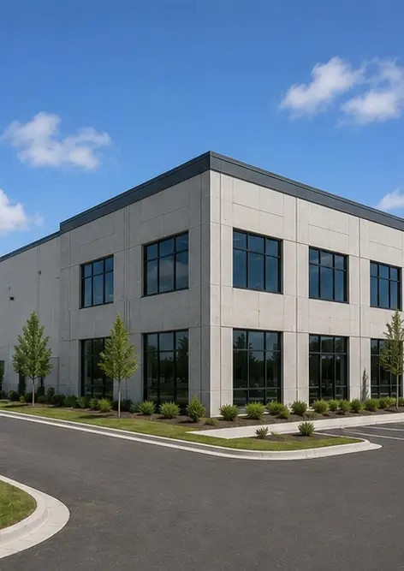

Create your own photo report online

Use Photo Reports to create structured PDF and Word photo reports with layouts, captions and export tools.

• Automatic page layouts
• PDF and DOCX export
• Photo captions and comments
• Before and after reports
• Inspection and maintenance reports
https://photo-reports.online

