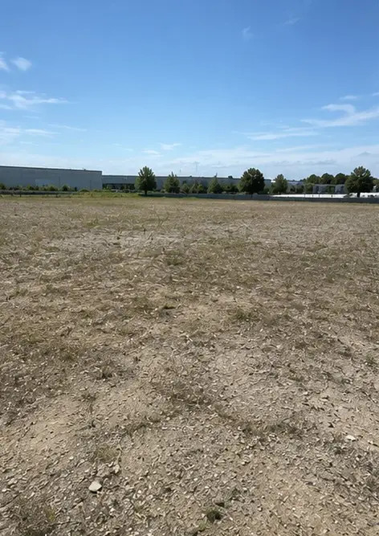 | Photo #1. Project site before commencement of work
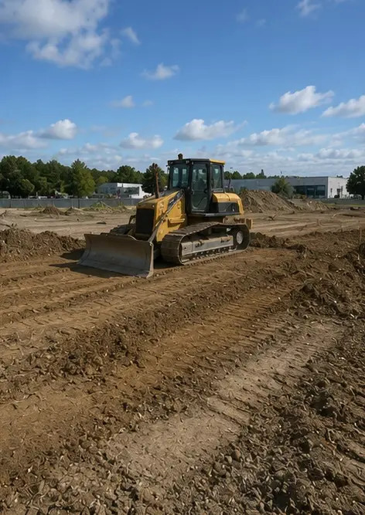 | Photo #2. Site preparation activities in progress
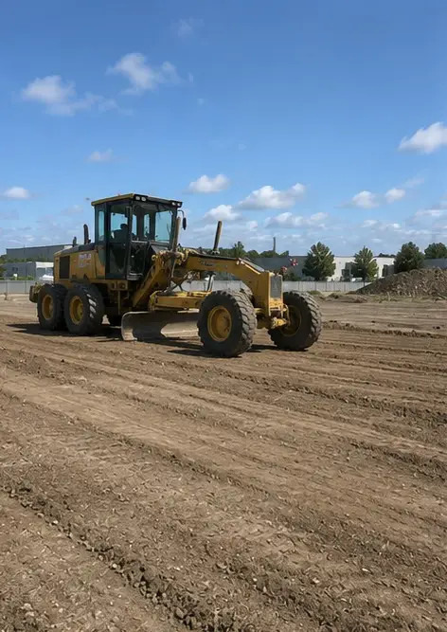 | Photo #3. Ground clearing and leveling completed
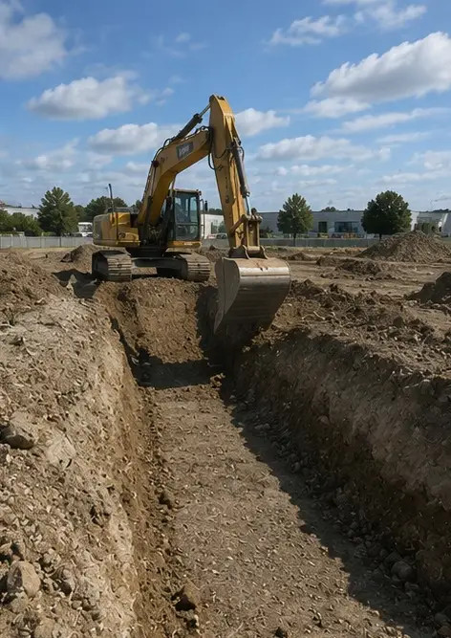 | Photo #4. Initial excavation work completed
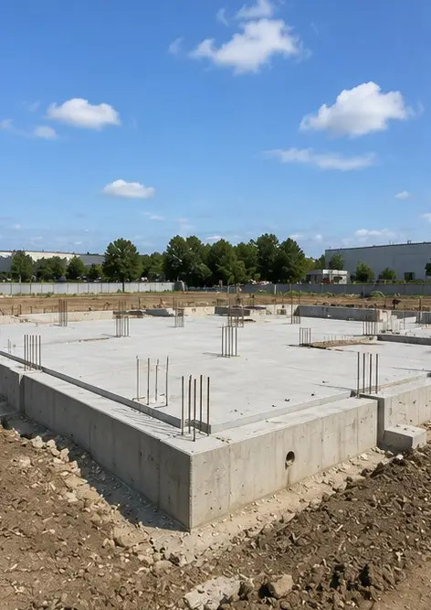 | Photo #5. Foundation construction completed
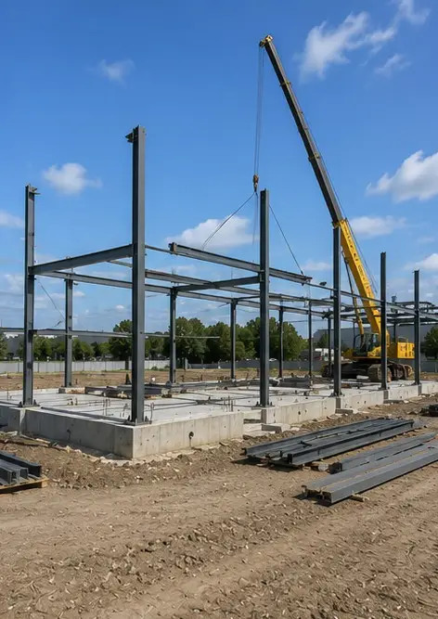 | Photo #6. Structural frame assembly started
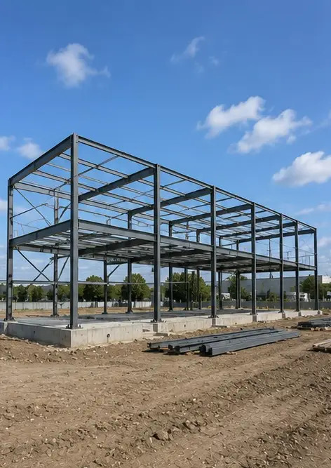 | Photo #7. Structural frame construction in progress
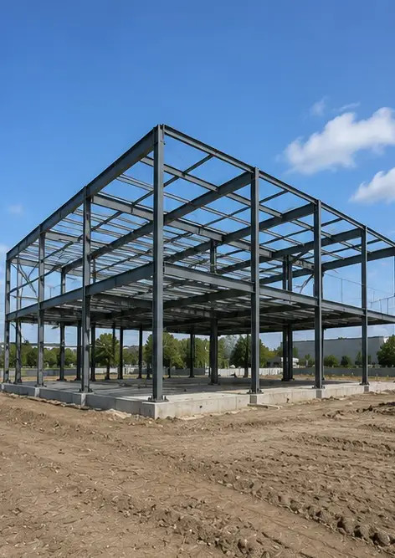 | Photo #8. Structural frame completed according to project schedule
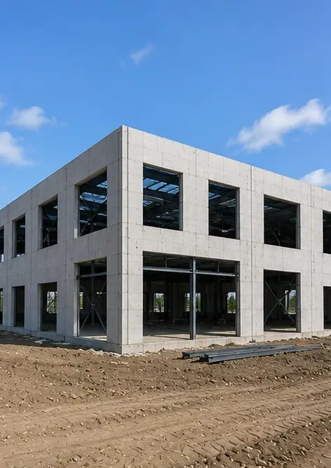 | Photo #9. Structural frame completed according to project schedule
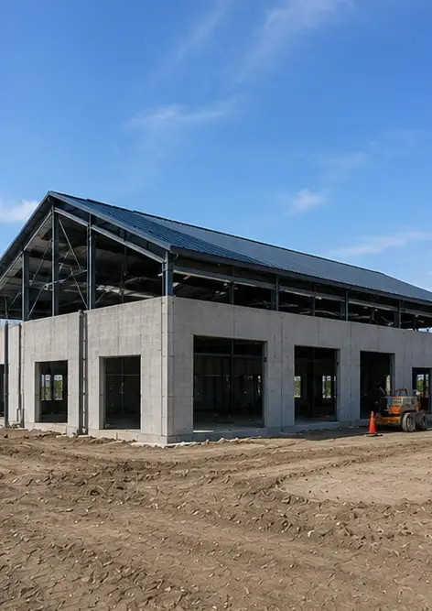 | Photo #10. Roof construction completed
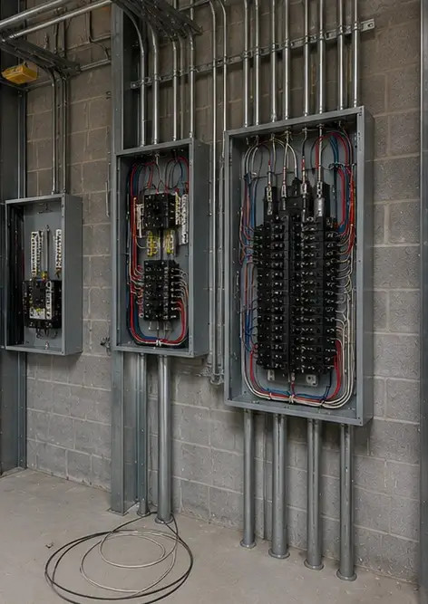 | Photo #11. Electrical systems installation in progress
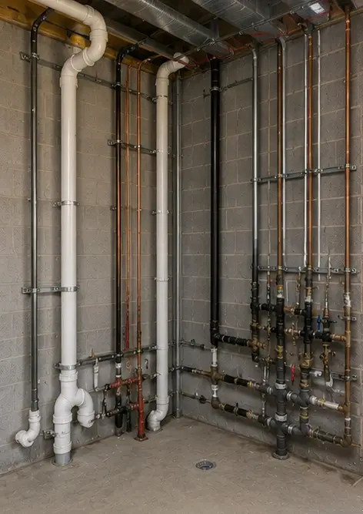 | Photo #12. Plumbing systems installation completed
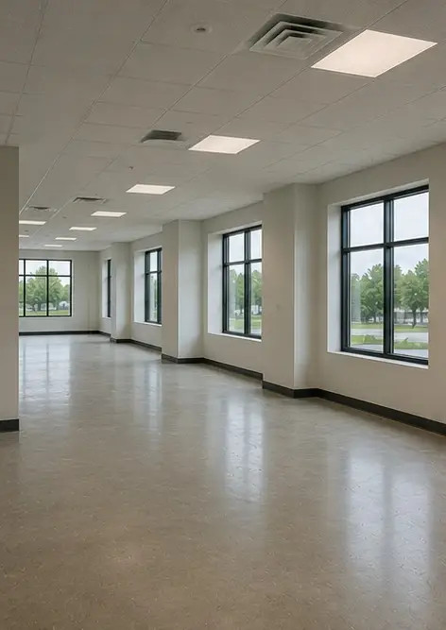 | Photo #13. Interior finishing work in progress
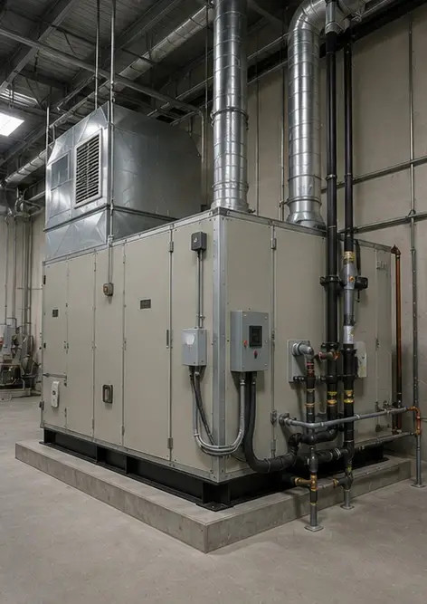 | Photo #14. Equipment installation completed
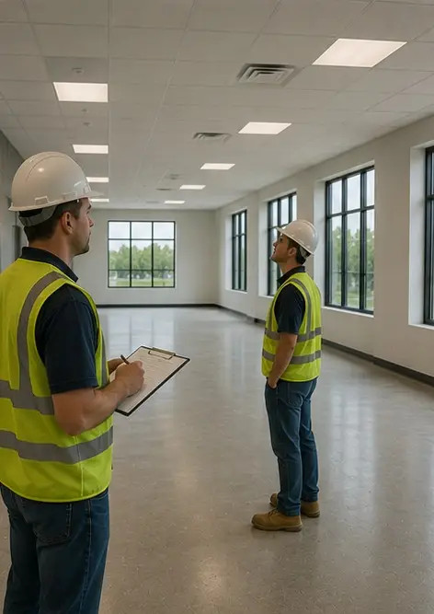 | Photo #15. Final project inspection conducted
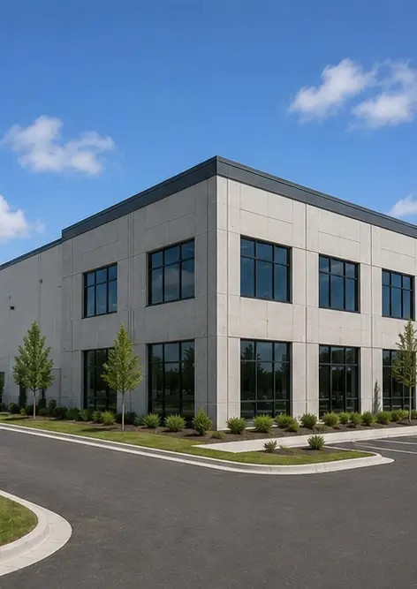 | Photo #16. Completed project ready for operation

Create your own photo report online

Use Photo Reports to create structured PDF and Word photo reports with layouts, captions and export tools.

• Automatic page layouts
• PDF and DOCX export
• Photo captions and comments
• Before and after reports
• Inspection and maintenance reports
https://photo-reports.online

