Photo #1. General overview of the industrial facility | 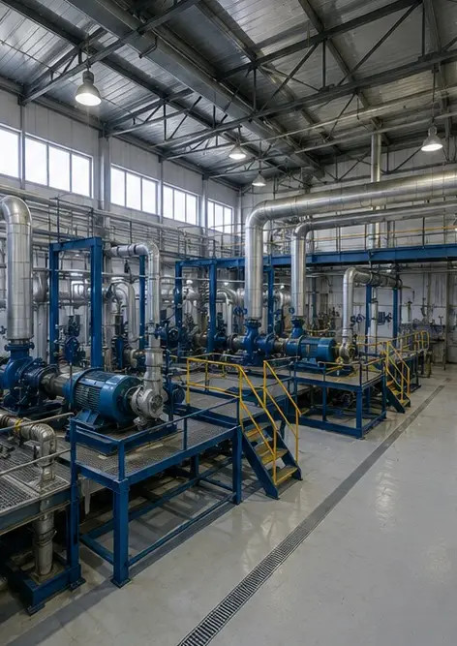
Photo #2. Mechanical equipment inspection completed | 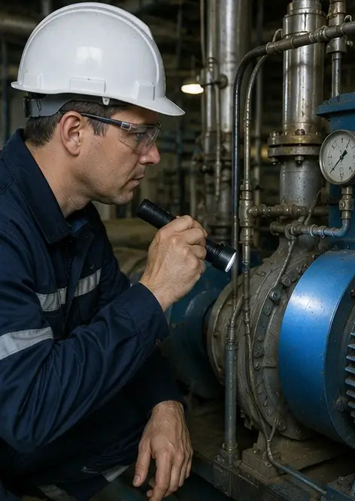
Photo #3. Industrial pump condition assessed during maintenance | 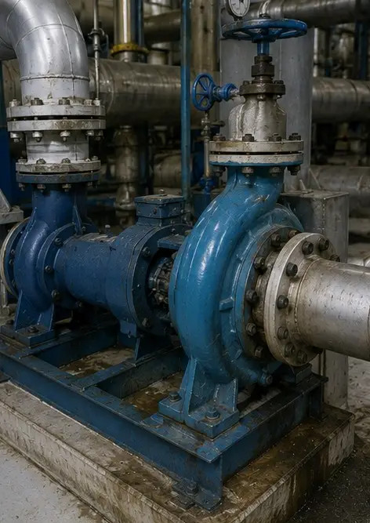
Photo #4. Electric motor inspection completed | 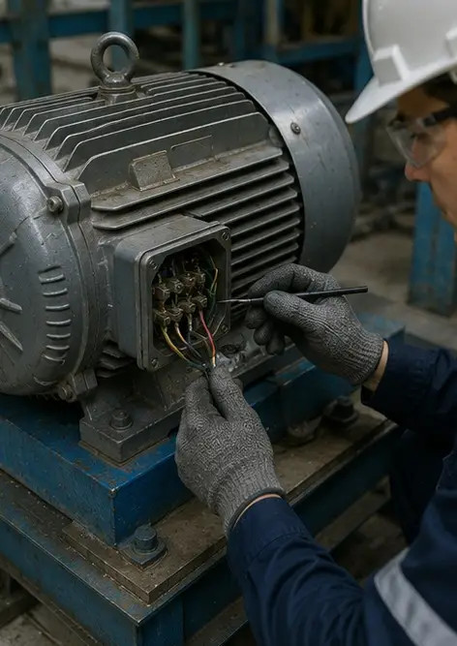
Photo #5. Electrical cabinet inspection performed | 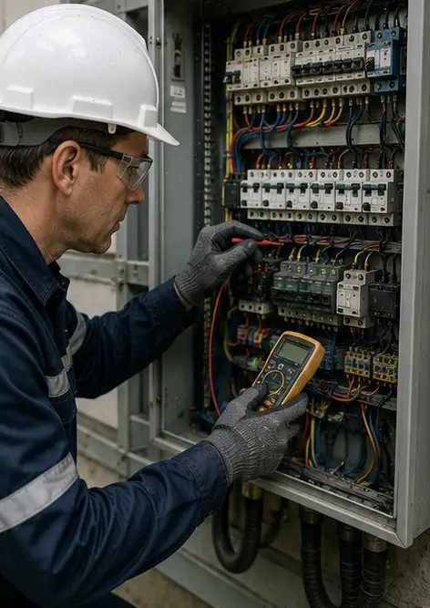
Photo #6. HVAC equipment condition documented | 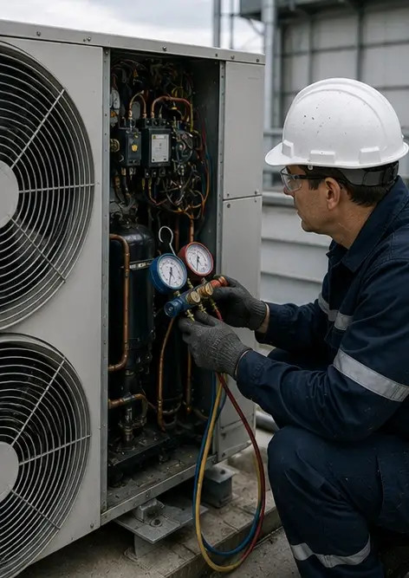
Photo #7. Air filter replacement completed | 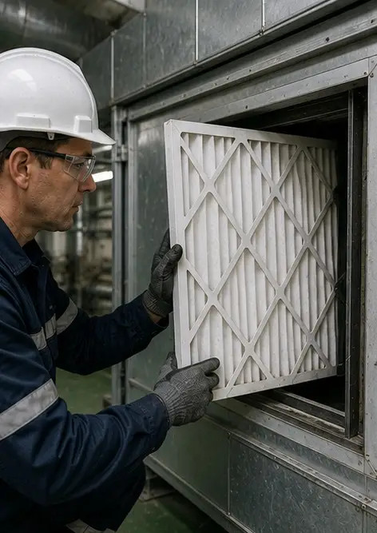
Photo #8. Ventilation system maintenance completed | 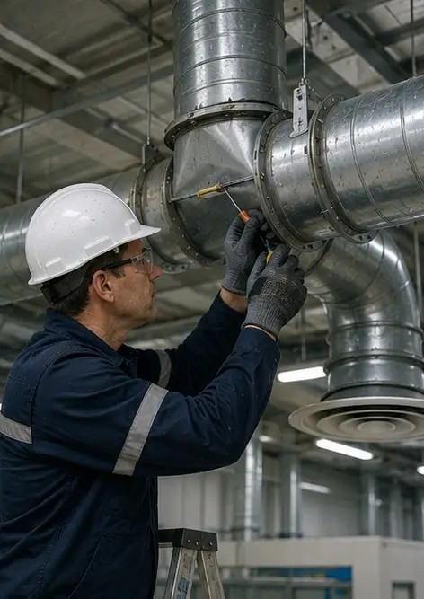
Photo #9. Pipe inspection completed according to maintenance schedule | 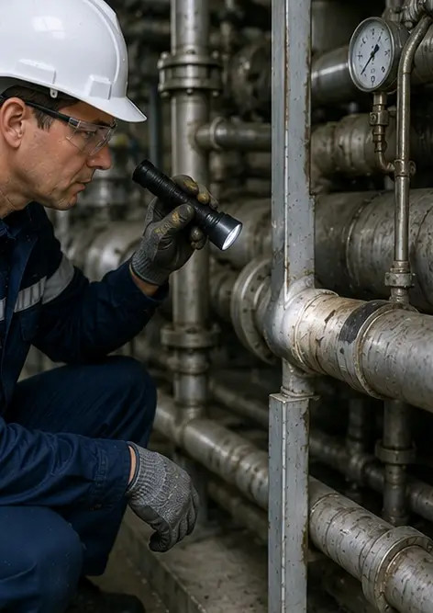
Photo #10. Valve condition assessed during inspection | 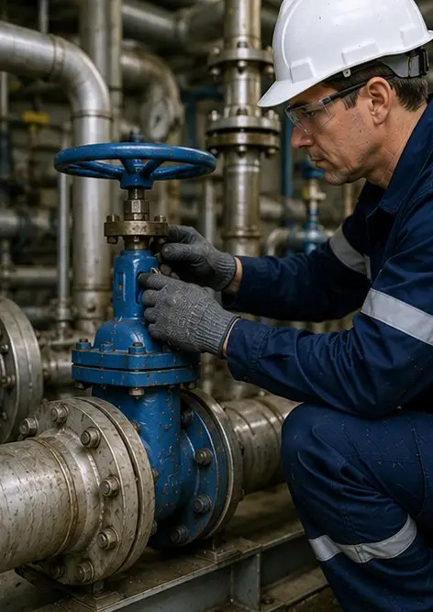
Photo #11. Lubrication work performed on equipment components | 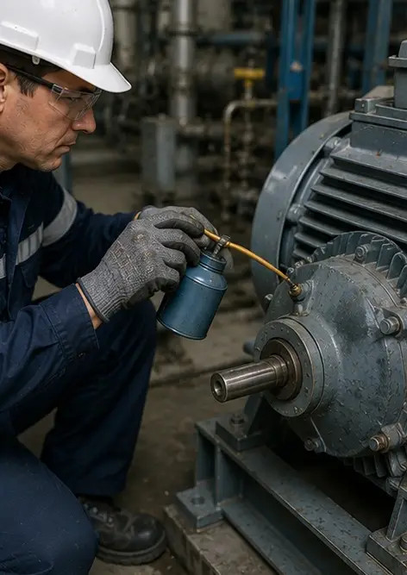
Photo #12. Equipment cleaning procedure completed | 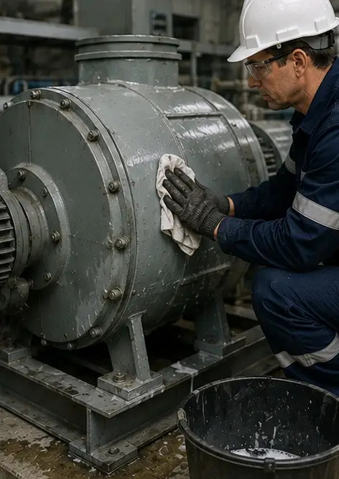
Photo #13. Safety system inspection completed | 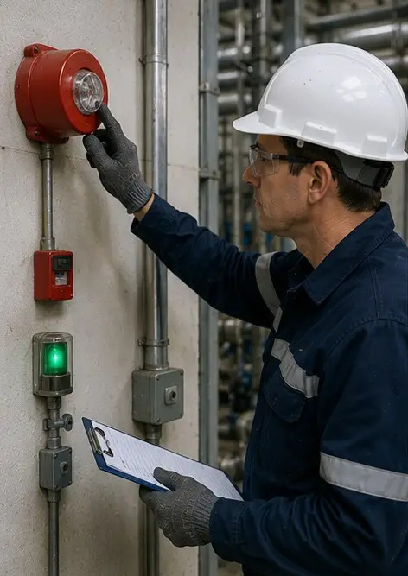
Photo #14. Final maintenance verification performed | 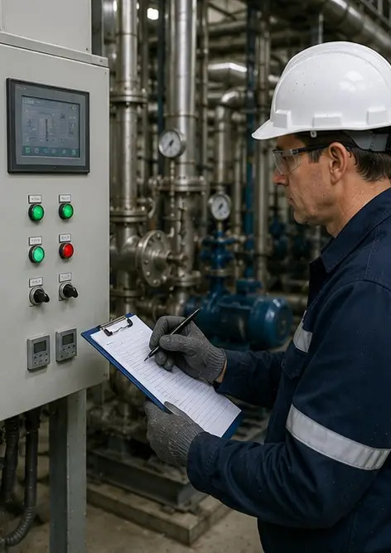
Photo #15. Equipment operating normally after maintenance | 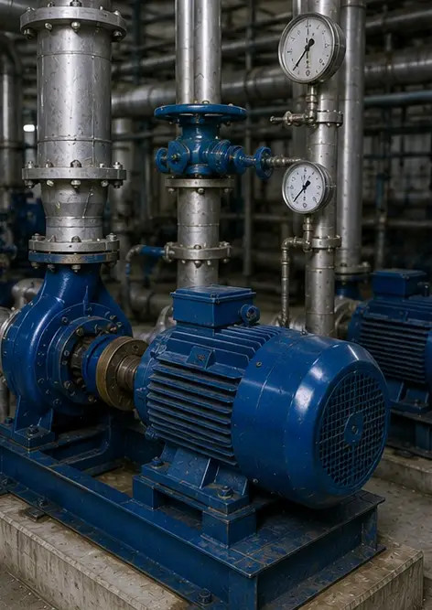
Photo #16. General facility overview after completion of maintenance work | 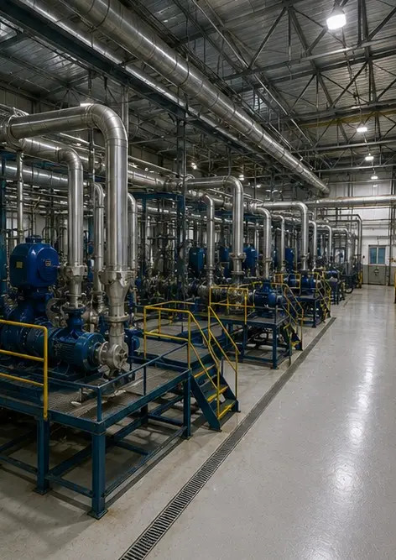

Create your own photo report online

Use Photo Reports to create structured PDF and Word photo reports with layouts, captions and export tools.

• Automatic page layouts
• PDF and DOCX export
• Photo captions and comments
• Before and after reports
• Inspection and maintenance reports
https://photo-reports.online

