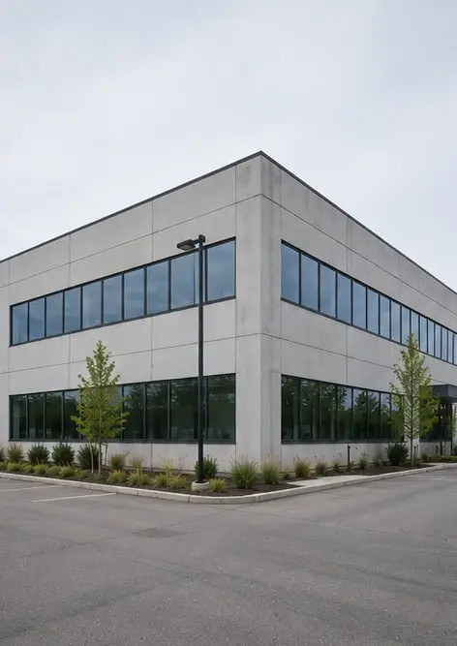 | 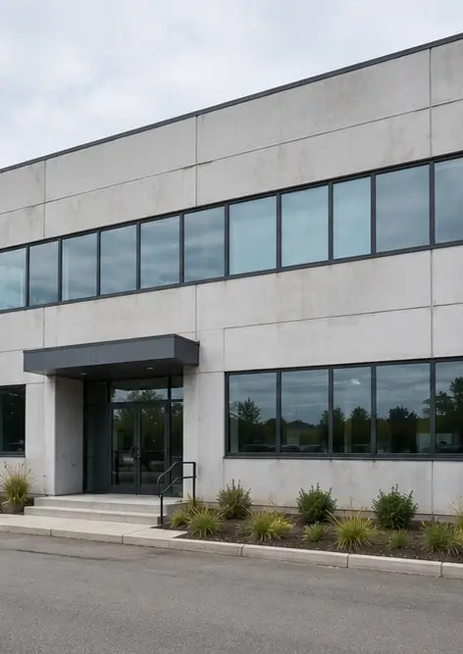 | 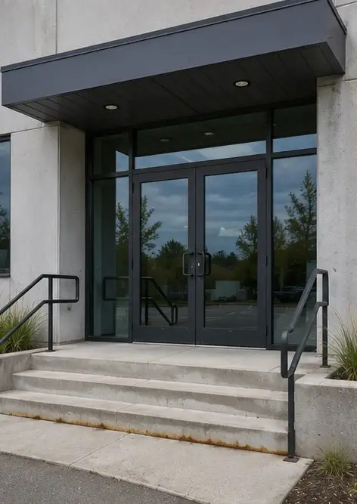
Photo #1 General view of the inspected property | Photo #2 Front facade condition during inspection | Photo #3 Main entrance area inspected and documented
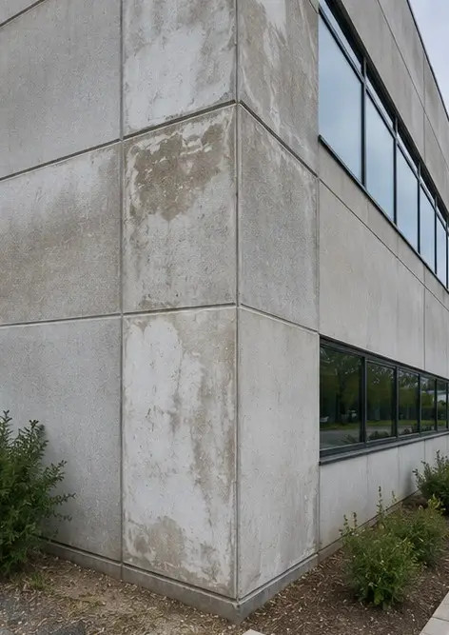 | 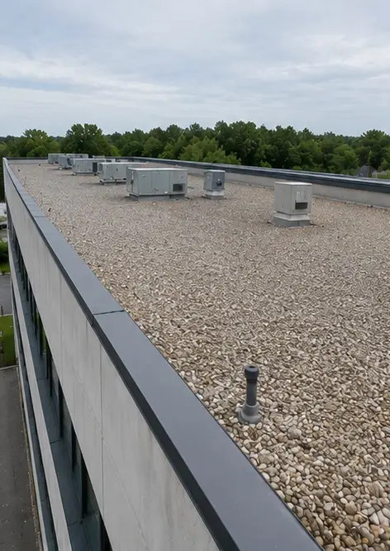 | 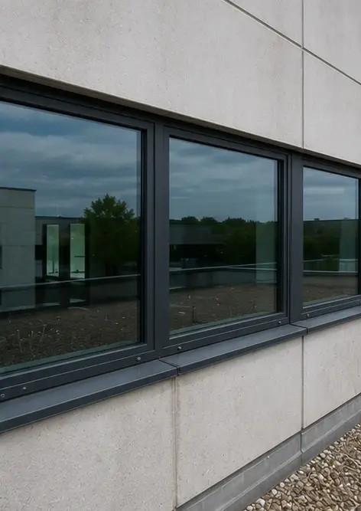
Photo #4 Exterior wall condition recorded during inspection | Photo #5 Roof condition inspection completed | Photo #6 Window condition documented during inspection
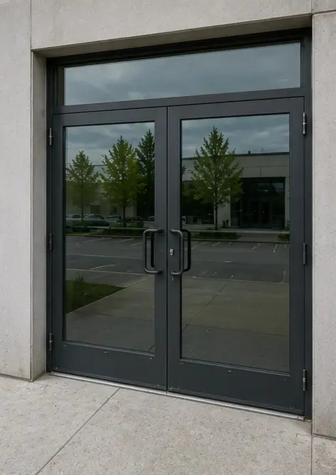 | 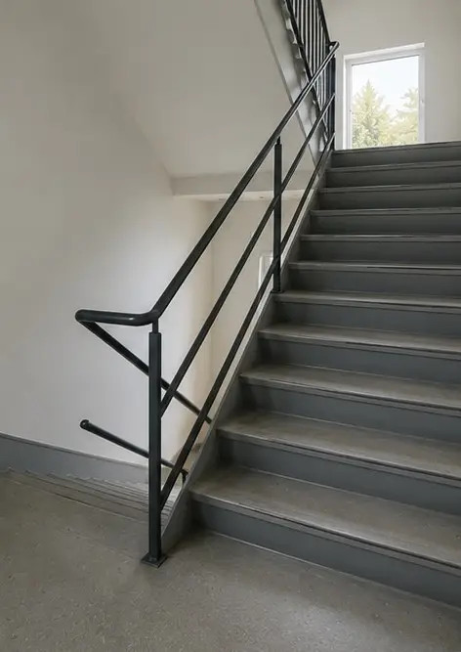 | 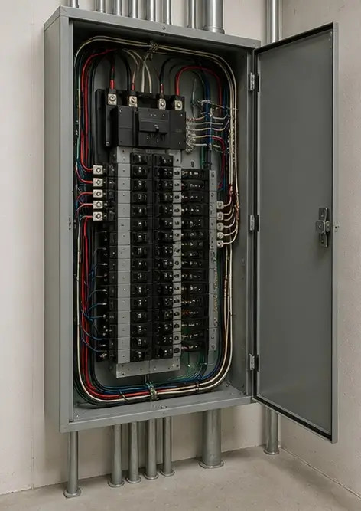
Photo #7 Door condition inspected and recorded | Photo #8 Staircase condition assessed during inspection | Photo #9 Electrical panel condition documented
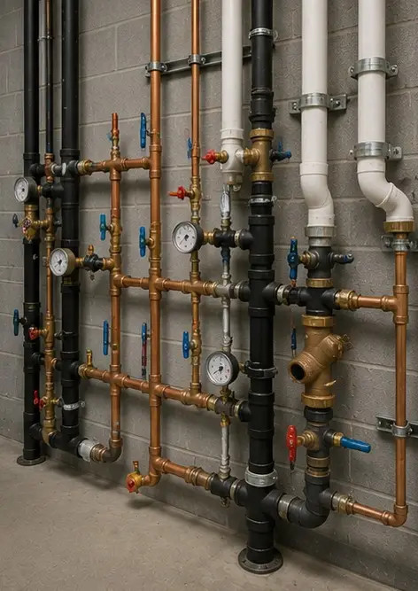 | 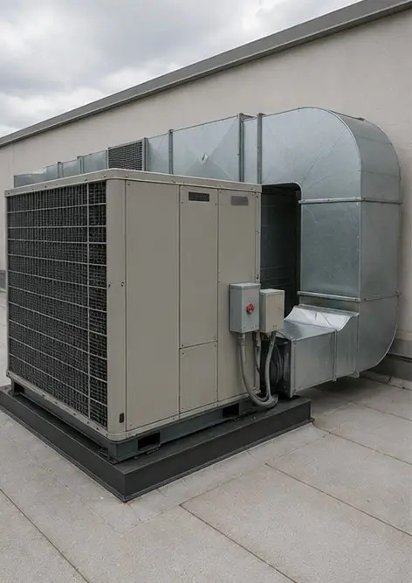 | 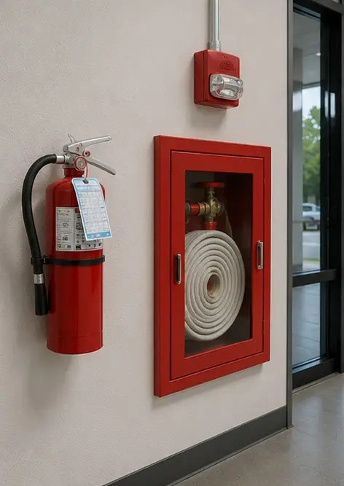
Photo #10 Plumbing system inspection completed | Photo #11 HVAC equipment condition assessed | Photo #12 Safety equipment inspected and recorded
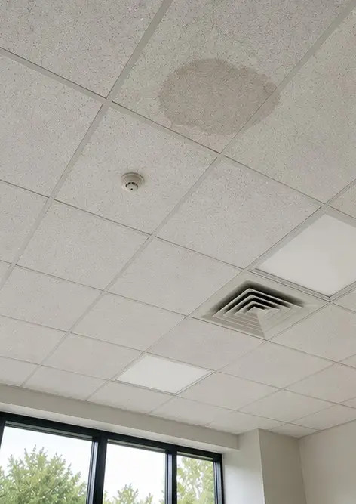 | 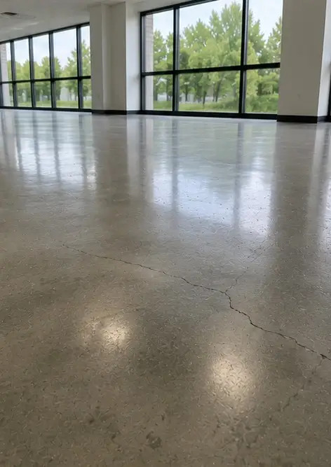 | 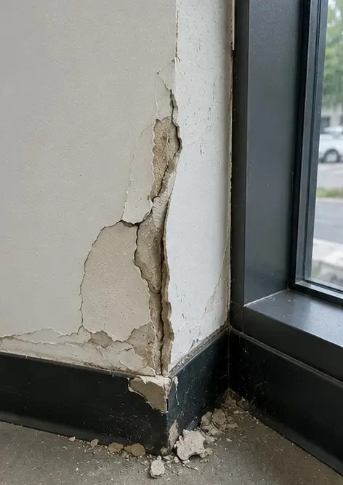
Photo #13 Ceiling condition documented during inspection | Photo #14 Floor condition assessed and recorded | Photo #15 Identified defect area documented for further evaluation
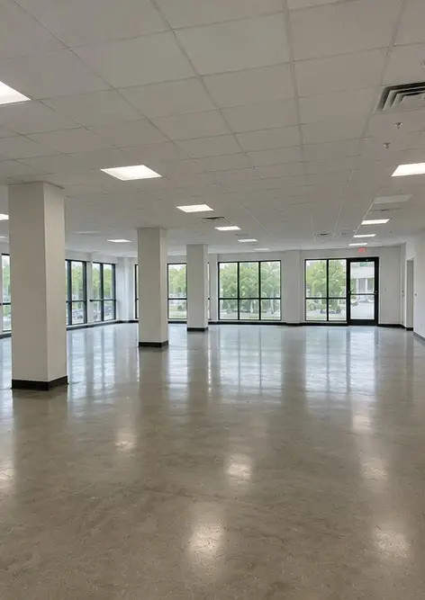
Photo #16 Final overview of the inspected property

Create your own photo report online

Use Photo Reports to create structured PDF and Word photo reports with layouts, captions and export tools.

• Automatic page layouts
• PDF and DOCX export
• Photo captions and comments
• Before and after reports
• Inspection and maintenance reports
https://photo-reports.online

