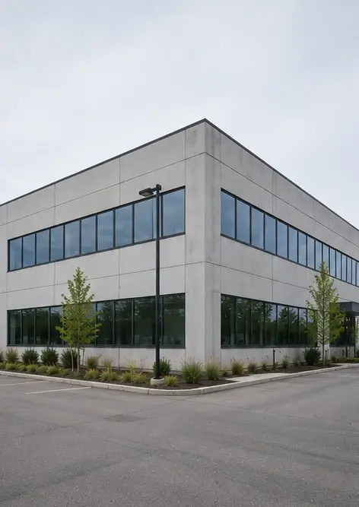 | Photo #1. General view of the inspected property
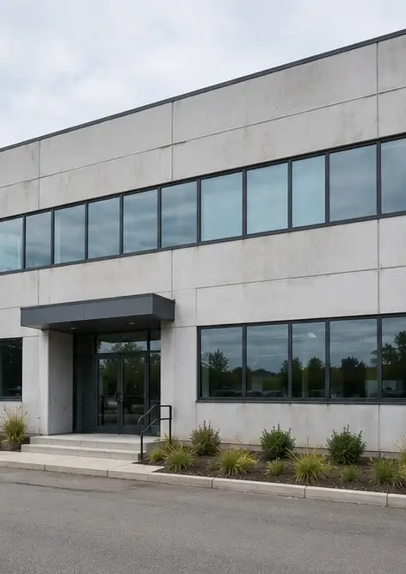 | Photo #2. Front facade condition during inspection
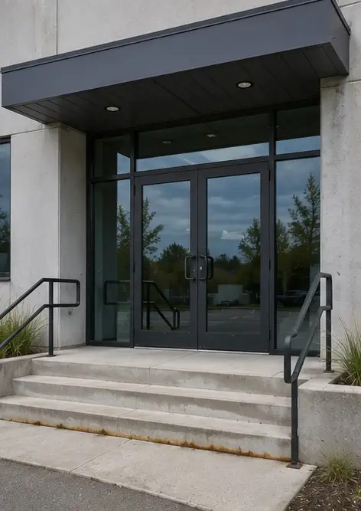 | Photo #3. Main entrance area inspected and documented
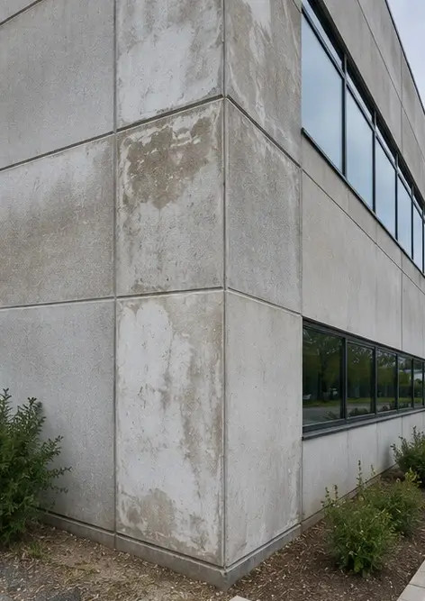 | Photo #4. Exterior wall condition recorded during inspection
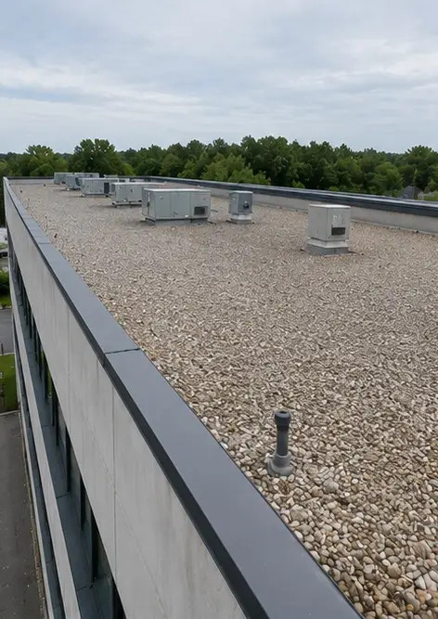 | Photo #5. Roof condition inspection completed
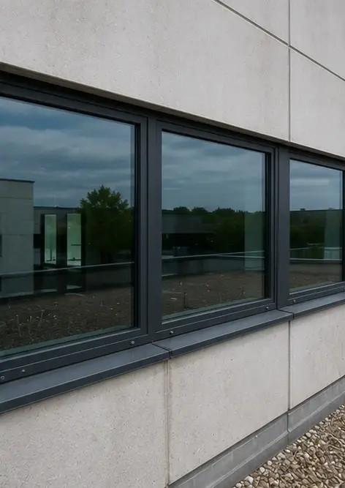 | Photo #6. Window condition documented during inspection
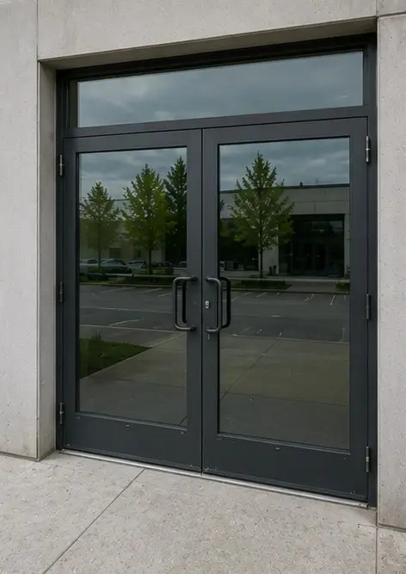 | Photo #7. Door condition inspected and recorded
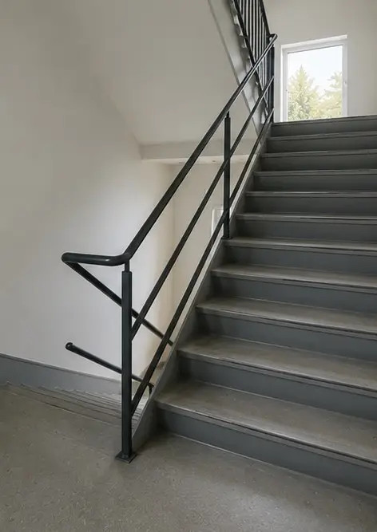 | Photo #8. Staircase condition assessed during inspection
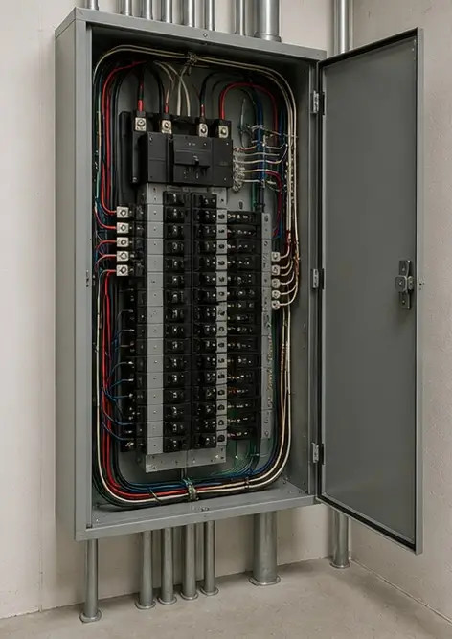 | Photo #9. Electrical panel condition documented
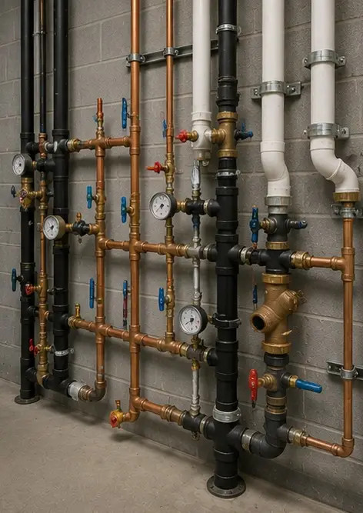 | Photo #10. Plumbing system inspection completed
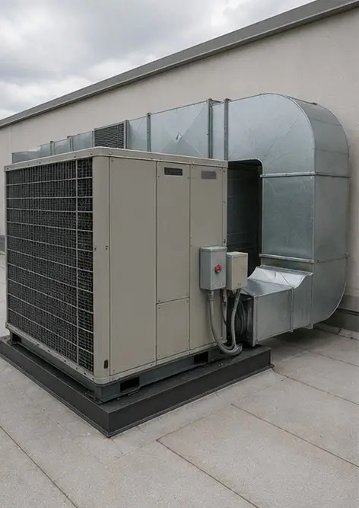 | Photo #11. HVAC equipment condition assessed
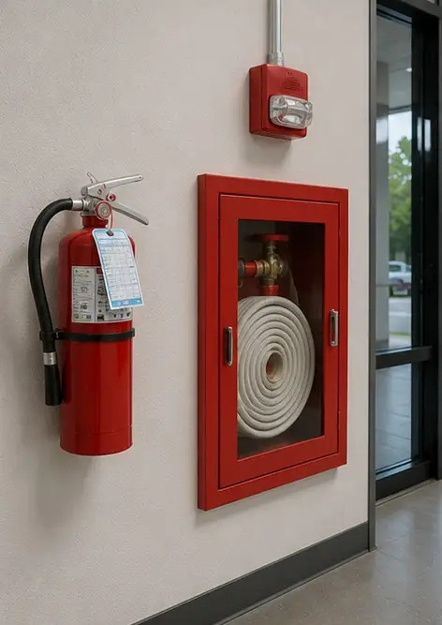 | Photo #12. Safety equipment inspected and recorded
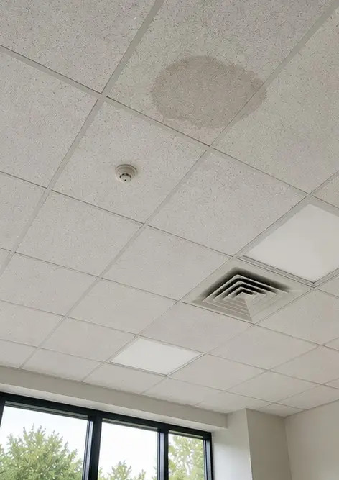 | Photo #13. Ceiling condition documented during inspection
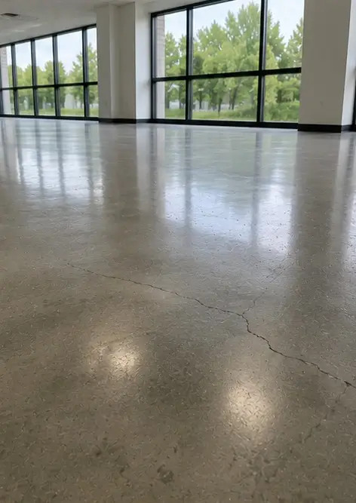 | Photo #14. Floor condition assessed and recorded
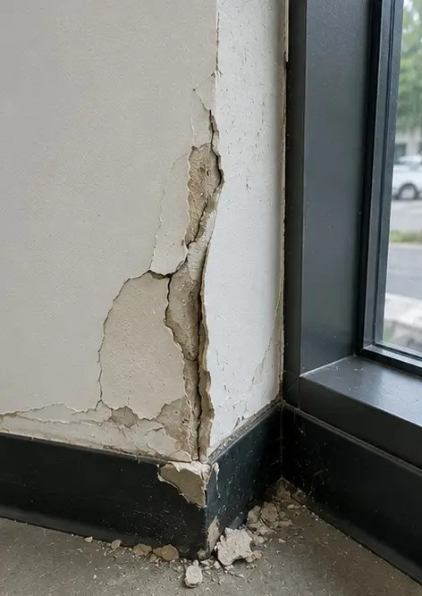 | Photo #15. Identified defect area documented for further evaluation
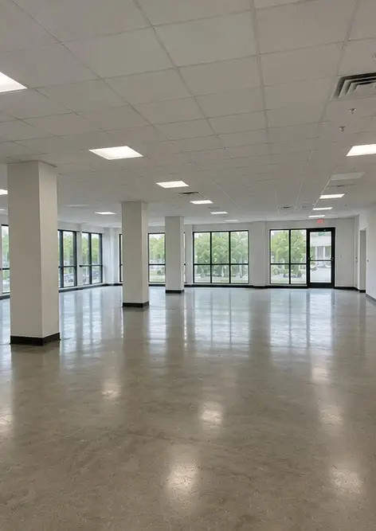 | Photo #16. Final overview of the inspected property

Create your own photo report online

Use Photo Reports to create structured PDF and Word photo reports with layouts, captions and export tools.

• Automatic page layouts
• PDF and DOCX export
• Photo captions and comments
• Before and after reports
• Inspection and maintenance reports
https://photo-reports.online

