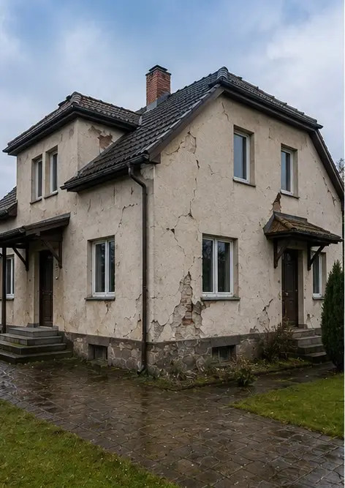 | 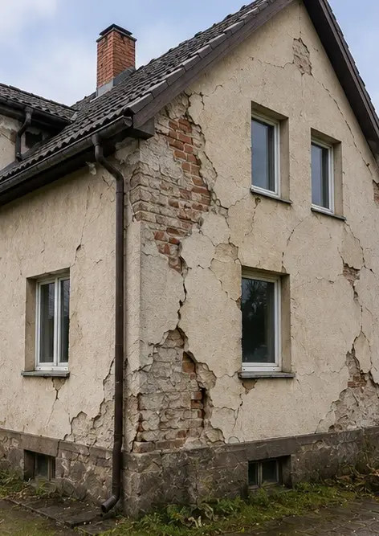
Photo #1. General view of the inspected property | Photo #2. Exterior damage overview documented during inspection
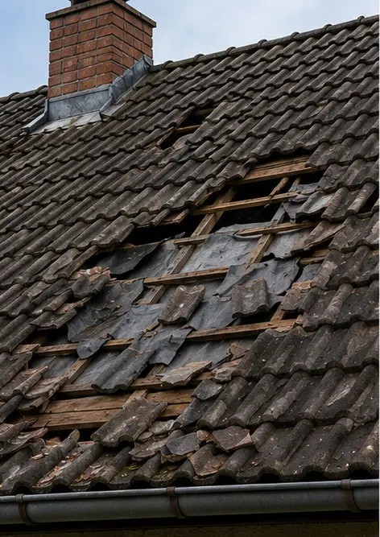 | 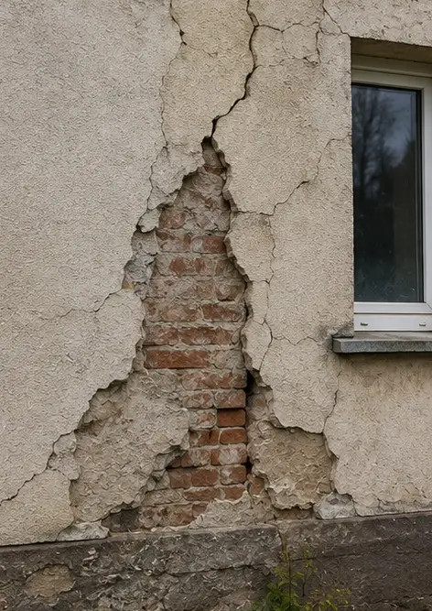
Photo #3. Damaged roof area identified and recorded | Photo #4. Exterior wall damage documented for assessment
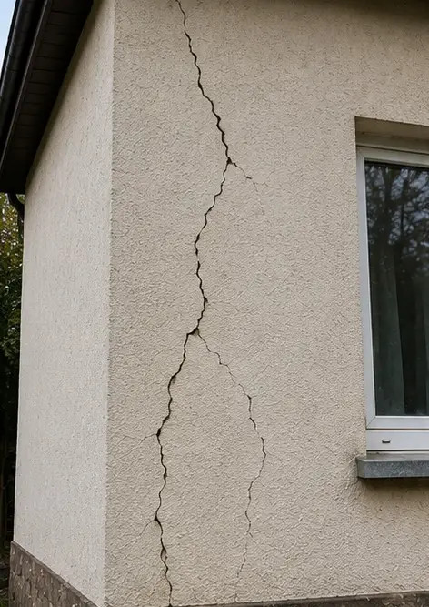 | 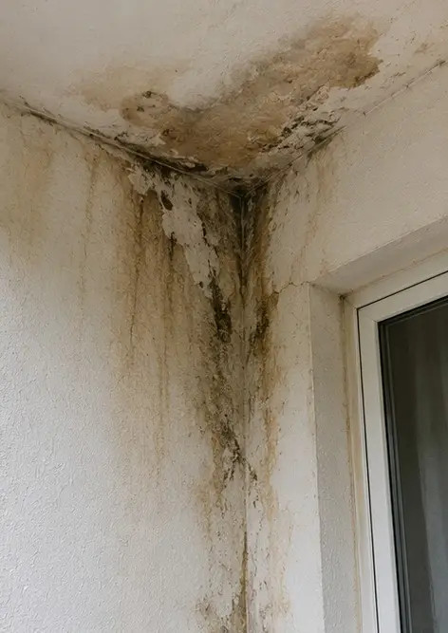
Photo #5. Structural wall crack documented during inspection | Photo #6. Water damage area identified and recorded
 | 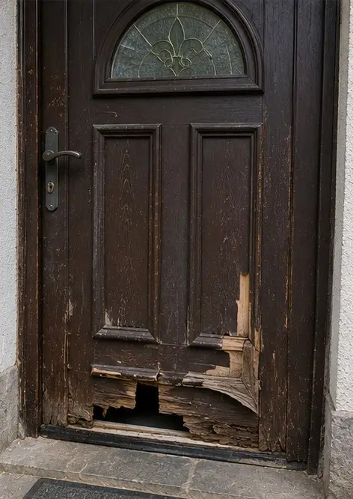
Photo #7. Damaged window documented for evaluation | Photo #8. Damaged entrance door recorded during inspection
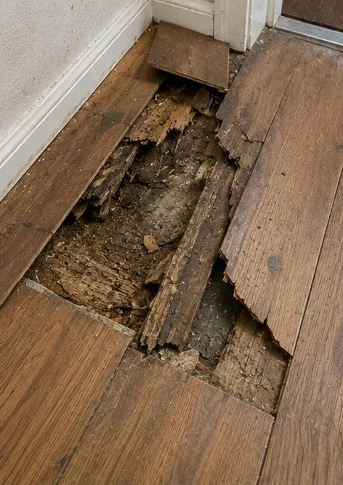 | 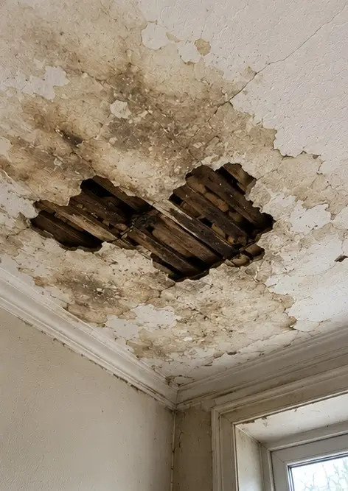
Photo #9. Damaged flooring documented during inspection | Photo #10. Ceiling damage identified and recorded
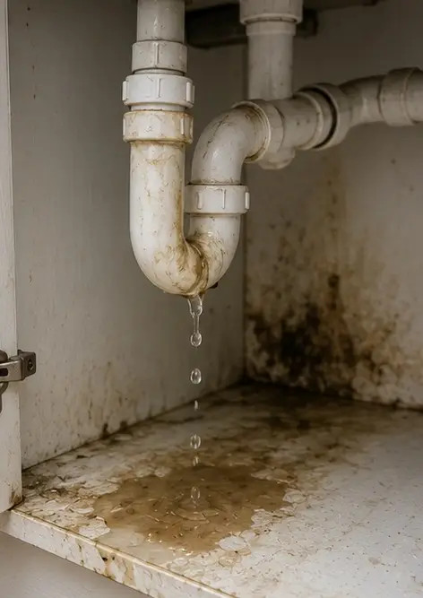 | 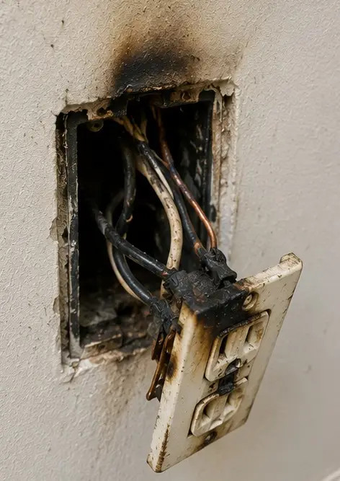
Photo #11. Plumbing leak damage documented | Photo #12. Electrical system damage recorded during inspection
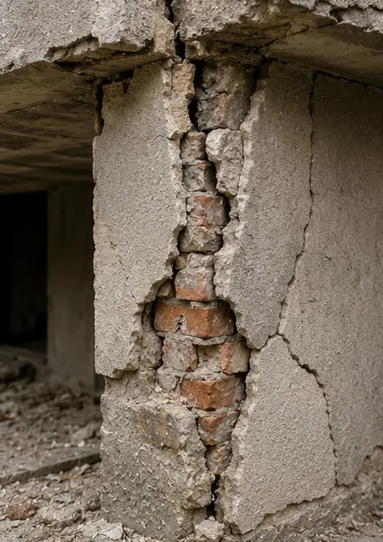 | 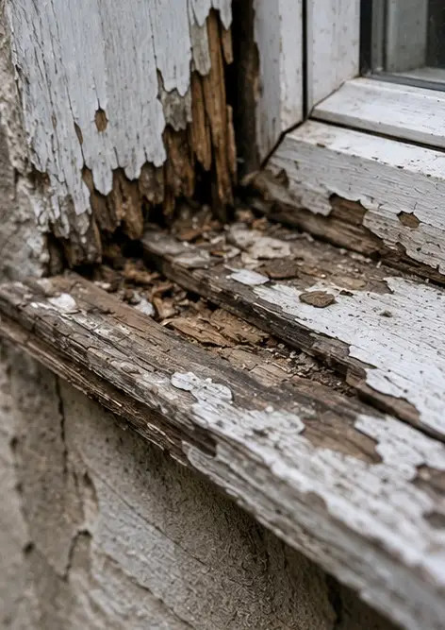
Photo #13. Structural damage detail documented for assessment | Photo #14. Close up evidence photograph of identified damage
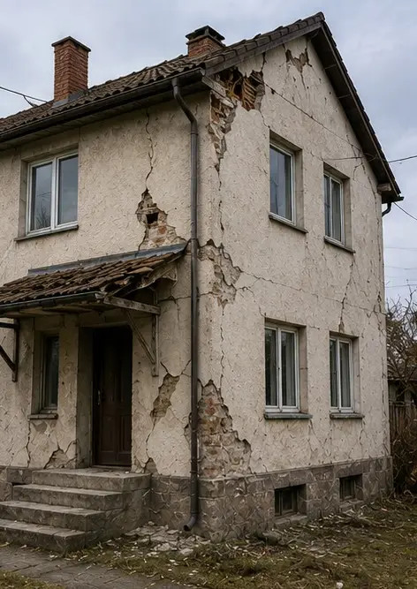 | 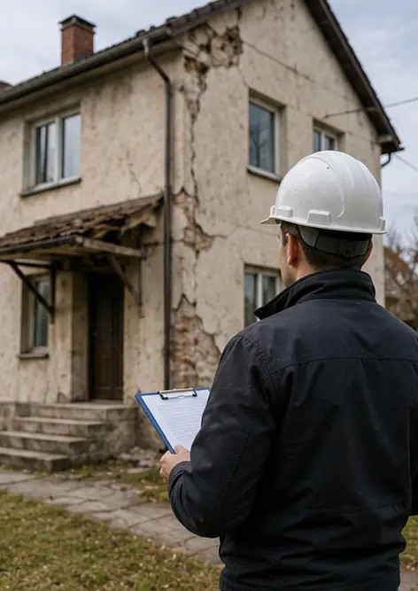
Photo #15. Overview of multiple damage locations | Photo #16. Final damage inspection summary photograph

Create your own photo report online

Use Photo Reports to create structured PDF and Word photo reports with layouts, captions and export tools.

• Automatic page layouts
• PDF and DOCX export
• Photo captions and comments
• Before and after reports
• Inspection and maintenance reports
https://photo-reports.online

