Photo #1 General view of the inspected property | 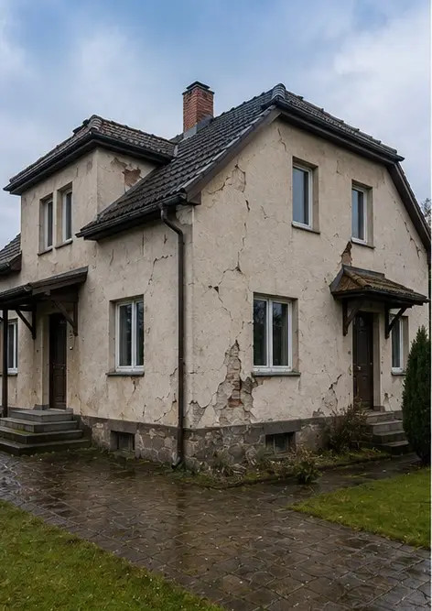
Photo #2 Exterior damage overview documented during inspection | 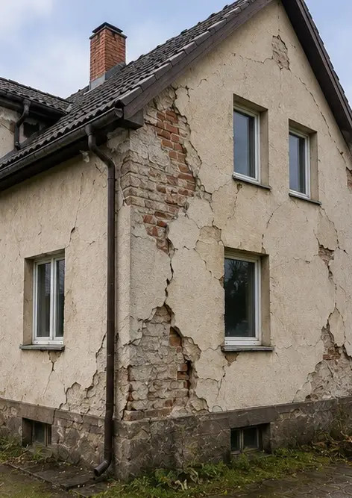
Photo #3 Damaged roof area identified and recorded | 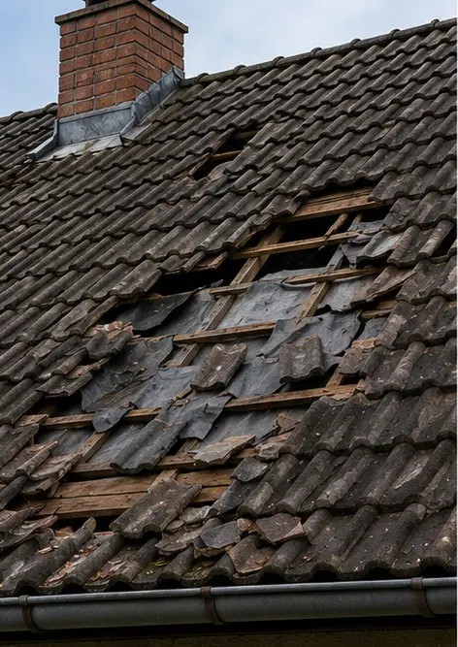
Photo #4 Exterior wall damage documented for assessment | 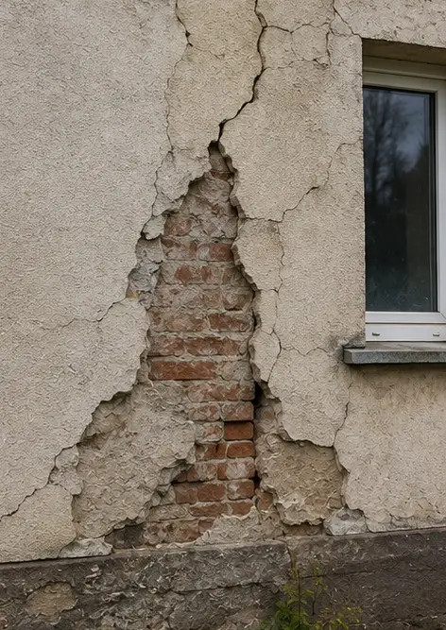
Photo #5 Structural wall crack documented during inspection | 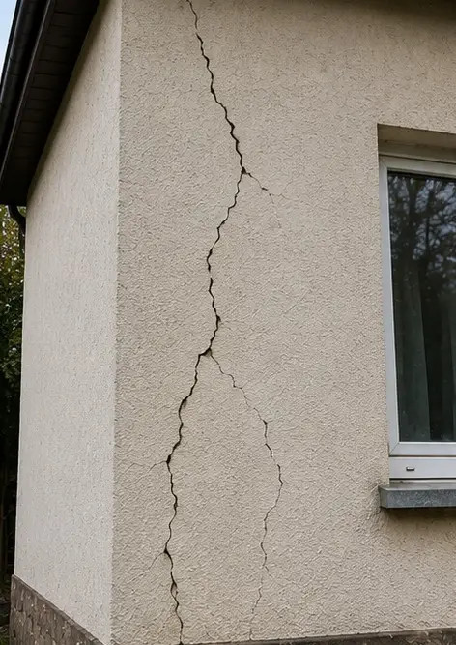
Photo #6 Water damage area identified and recorded | 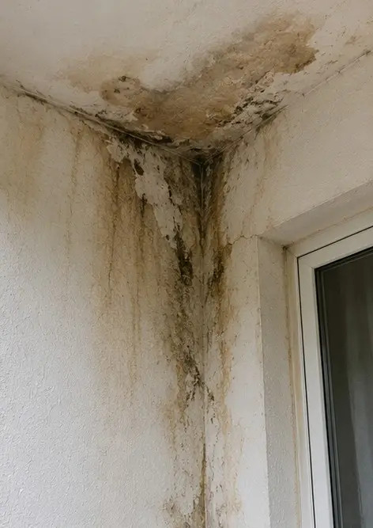
Photo #7 Damaged window documented for evaluation | 
Photo #8 Damaged entrance door recorded during inspection | 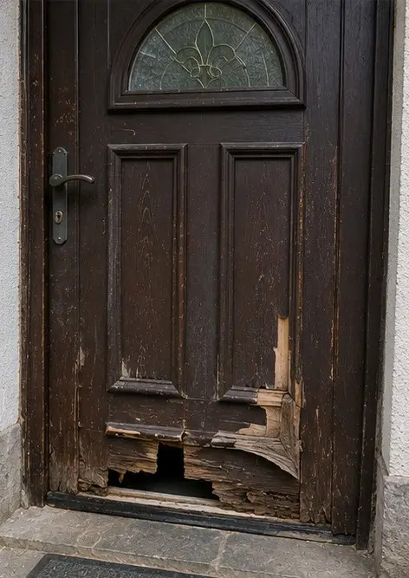
Photo #9 Damaged flooring documented during inspection | 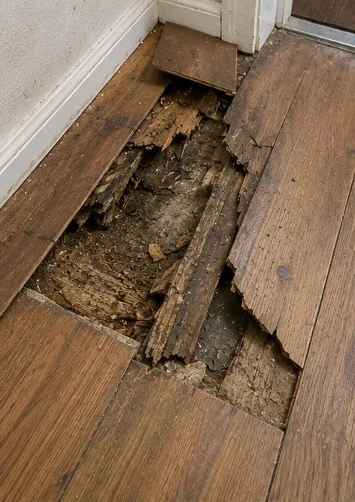
Photo #10 Ceiling damage identified and recorded | 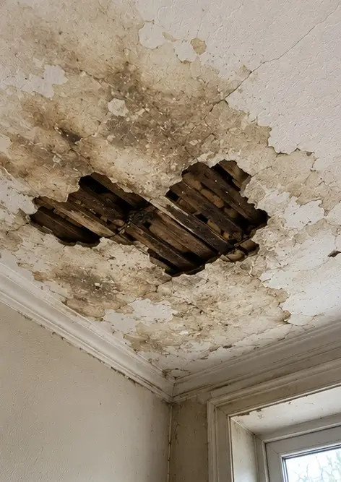
Photo #11 Plumbing leak damage documented | 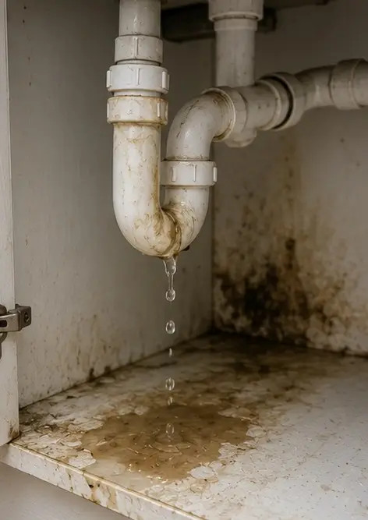
Photo #12 Electrical system damage recorded during inspection | 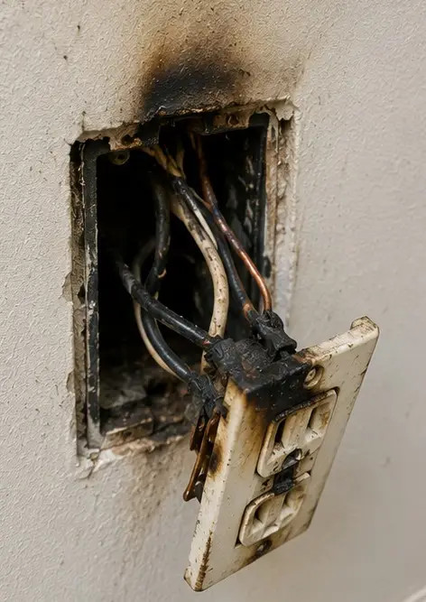
Photo #13 Structural damage detail documented for assessment | 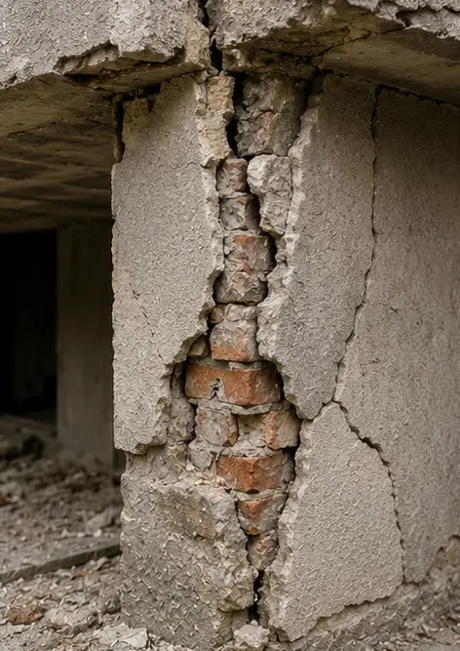
Photo #14 Close up evidence photograph of identified damage | 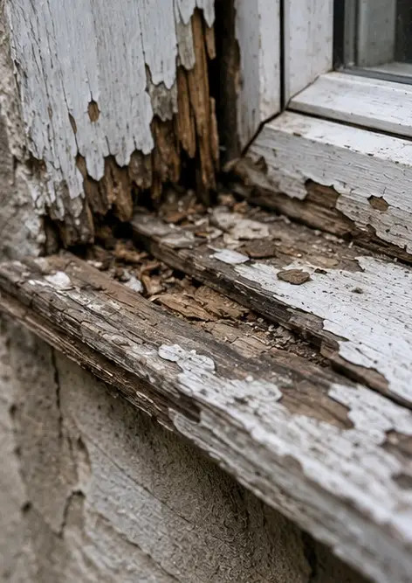
Photo #15 Overview of multiple damage locations | 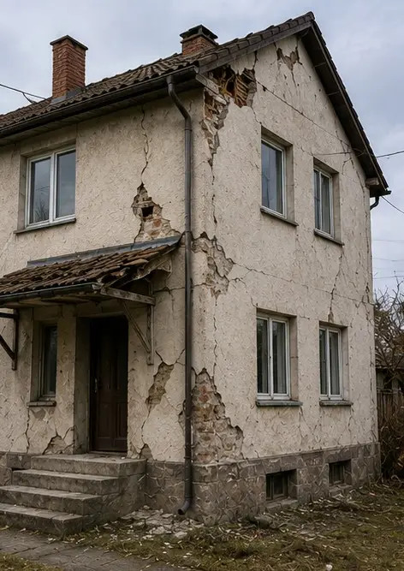
Photo #16 Final damage inspection summary photograph | 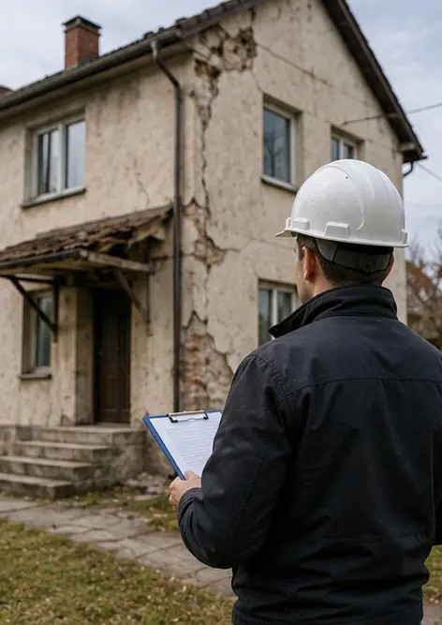

Create your own photo report online

Use Photo Reports to create structured PDF and Word photo reports with layouts, captions and export tools.

• Automatic page layouts
• PDF and DOCX export
• Photo captions and comments
• Before and after reports
• Inspection and maintenance reports
https://photo-reports.online

