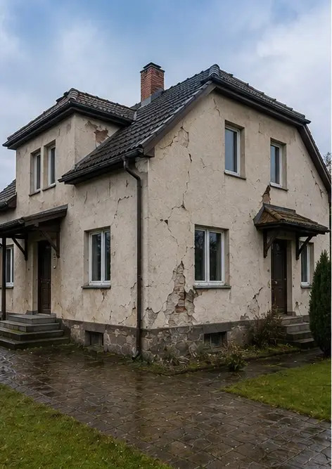 | 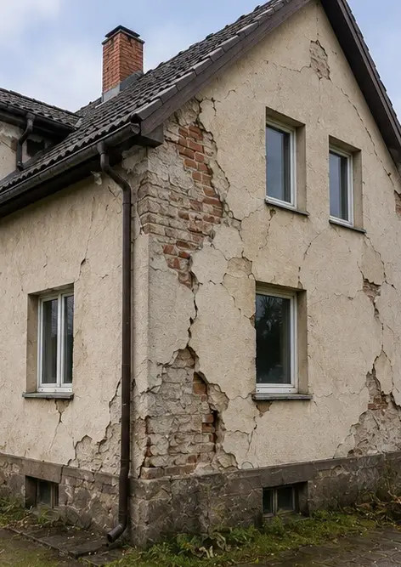 | 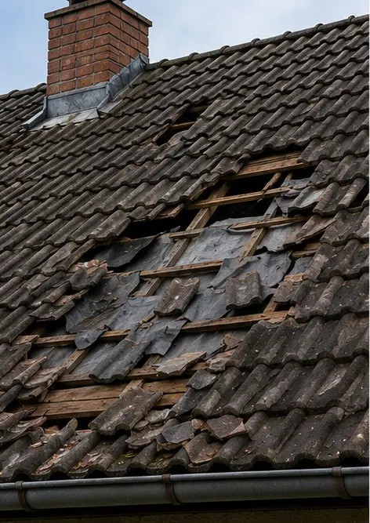
Photo #1 General view of the inspected property | Photo #2 Exterior damage overview documented during inspection | Photo #3 Damaged roof area identified and recorded
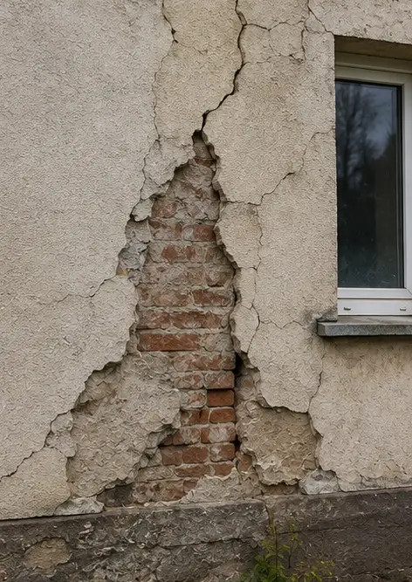 | 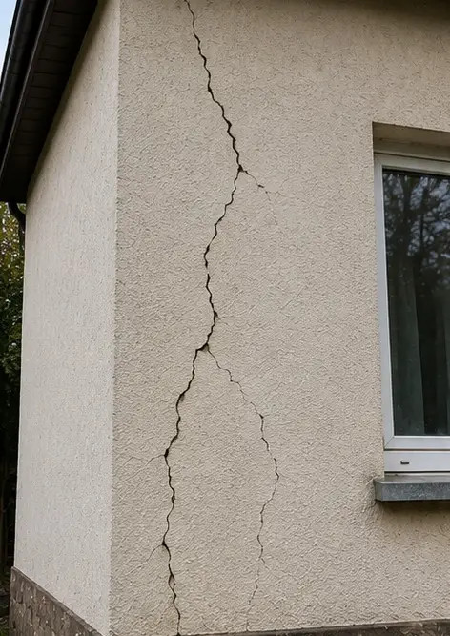 | 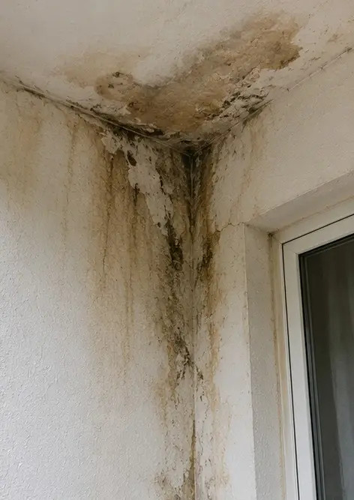
Photo #4 Exterior wall damage documented for assessment | Photo #5 Structural wall crack documented during inspection | Photo #6 Water damage area identified and recorded
 | 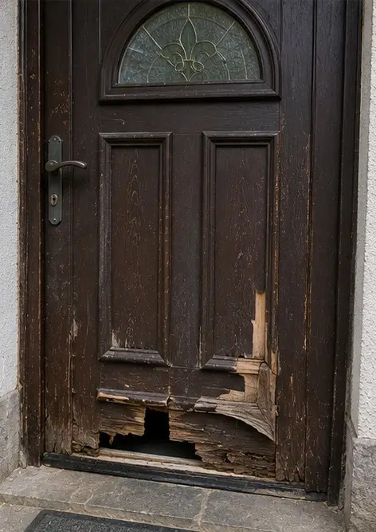 | 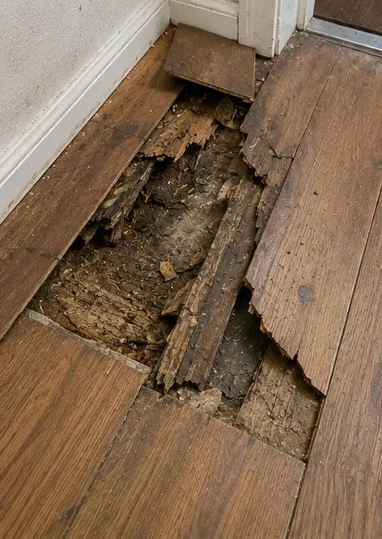
Photo #7 Damaged window documented for evaluation | Photo #8 Damaged entrance door recorded during inspection | Photo #9 Damaged flooring documented during inspection
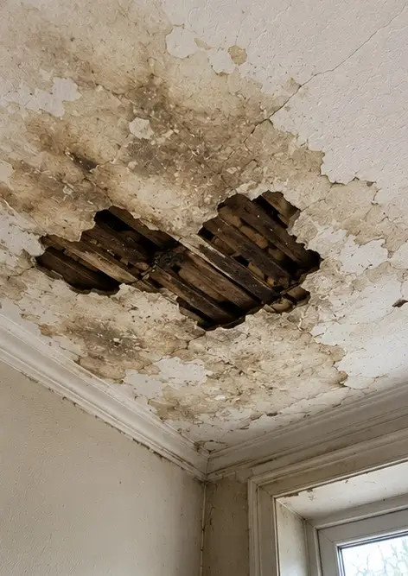 | 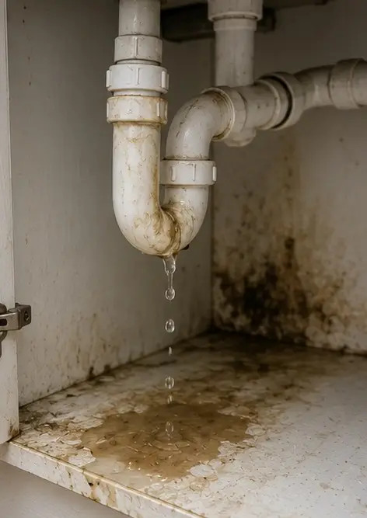 | 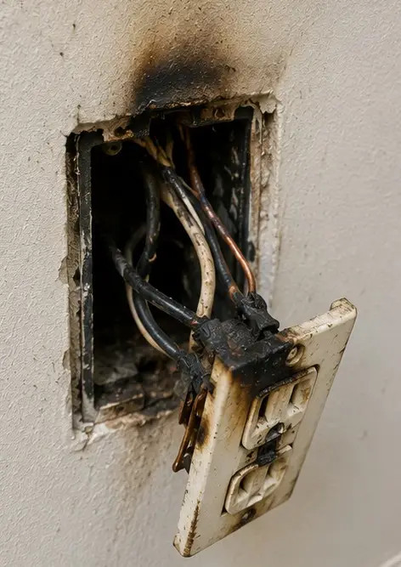
Photo #10 Ceiling damage identified and recorded | Photo #11 Plumbing leak damage documented | Photo #12 Electrical system damage recorded during inspection
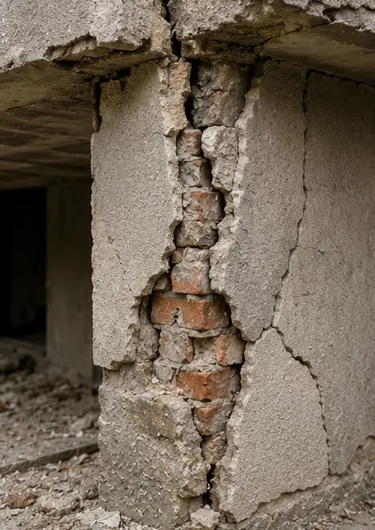 | 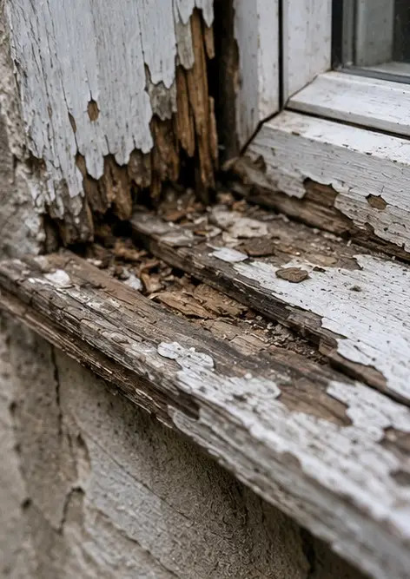 | 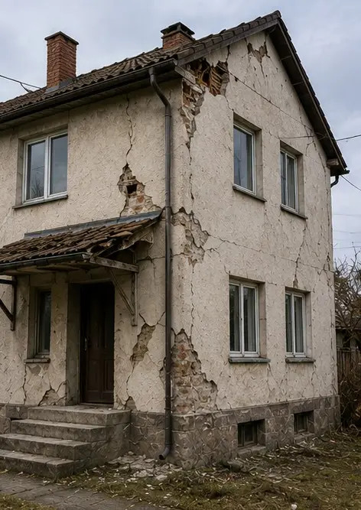
Photo #13 Structural damage detail documented for assessment | Photo #14 Close up evidence photograph of identified damage | Photo #15 Overview of multiple damage locations
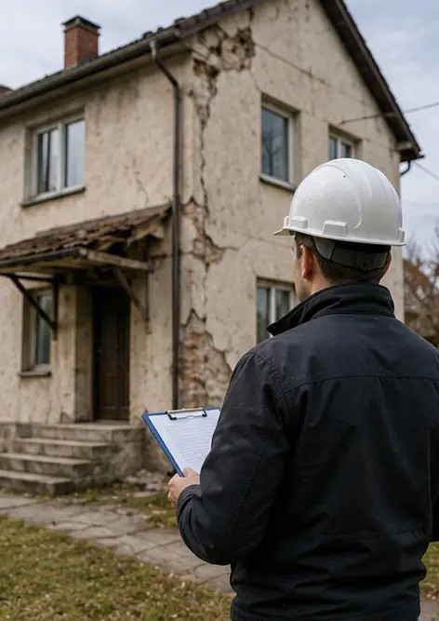
Photo #16 Final damage inspection summary photograph

Create your own photo report online

Use Photo Reports to create structured PDF and Word photo reports with layouts, captions and export tools.

• Automatic page layouts
• PDF and DOCX export
• Photo captions and comments
• Before and after reports
• Inspection and maintenance reports
https://photo-reports.online

