Photo #1 Site preparation work completed before the start of construction | 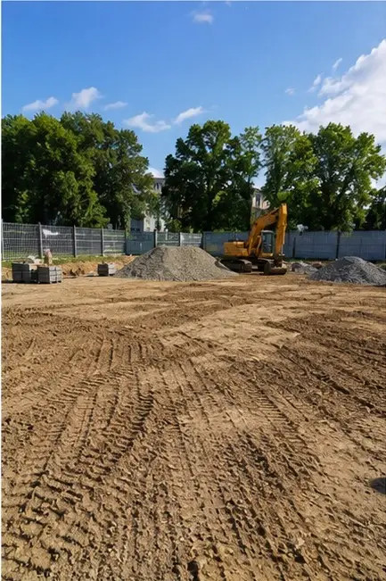
Photo #2 Excavation work performed according to project requirements | 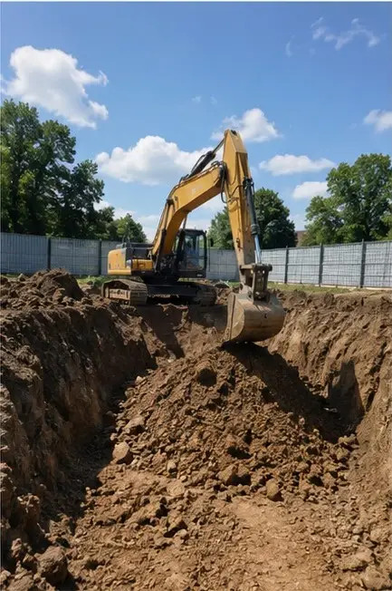
Photo #3 Foundation construction in progress | 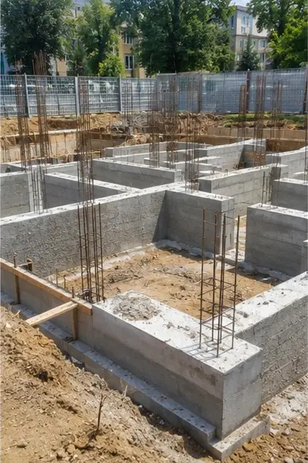
Photo #4 Reinforcement installation completed before concrete pouring | 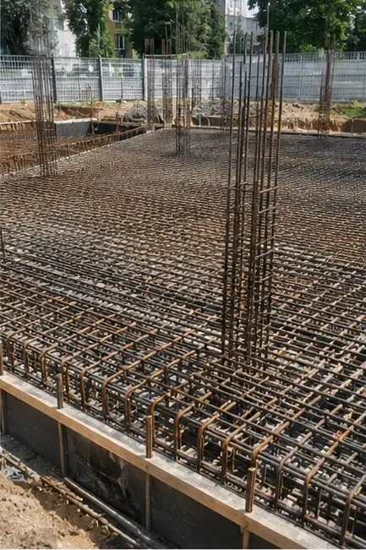
Photo #5 Concrete pouring operation performed on foundation elements | 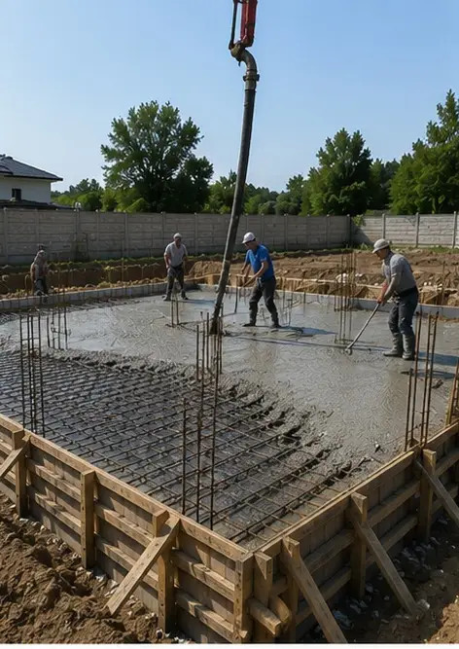
Photo #6 Structural frame assembly in progress | 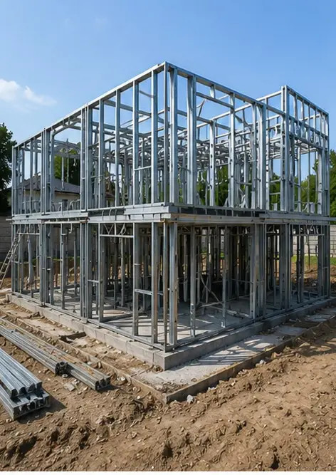
Photo #7 Exterior wall construction completed for the building section | 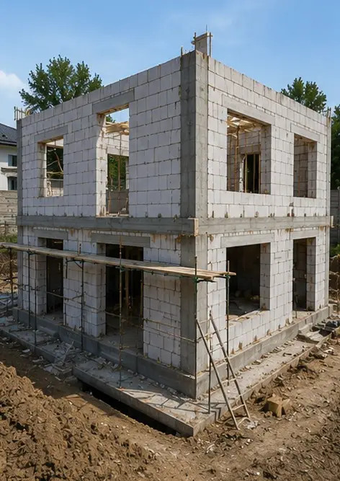
Photo #8 Roof installation work completed | 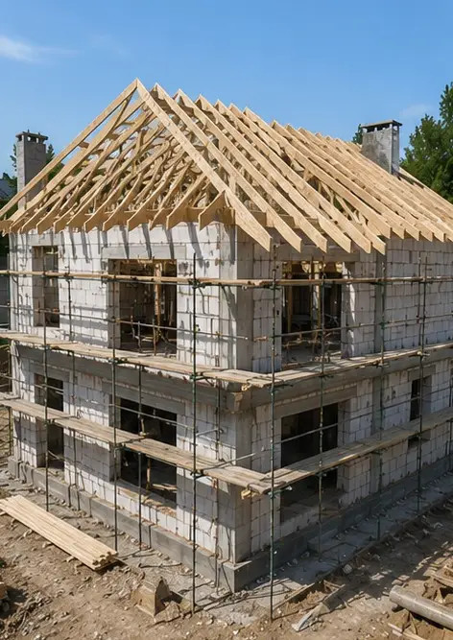
Photo #9 Electrical systems installation in progress | 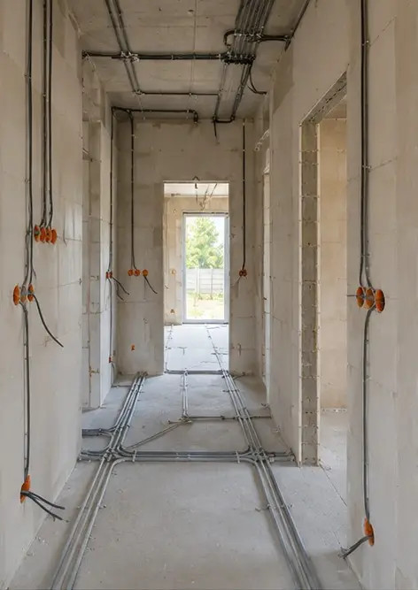
Photo #10 Plumbing systems installation completed in designated areas | 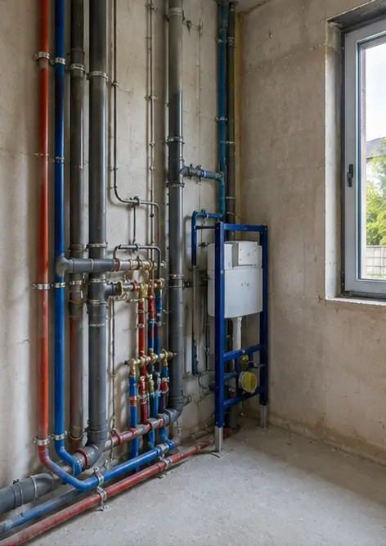
Photo #11 Interior wall finishing work in progress | 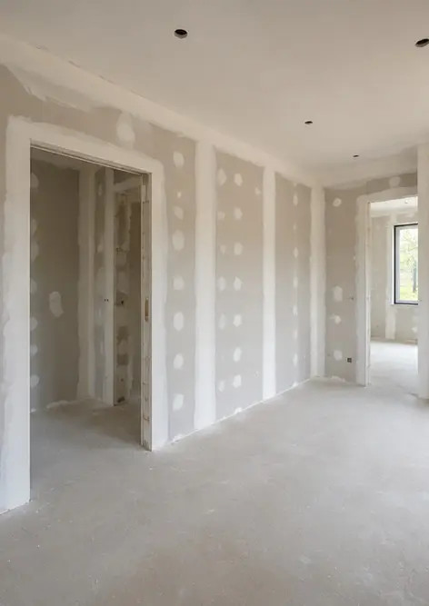
Photo #12 Flooring installation completed according to project specifications | 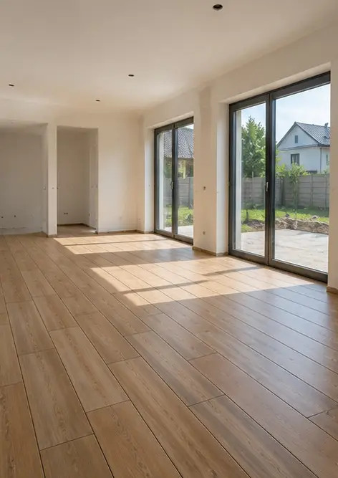
Photo #13 Final inspection of completed construction works | 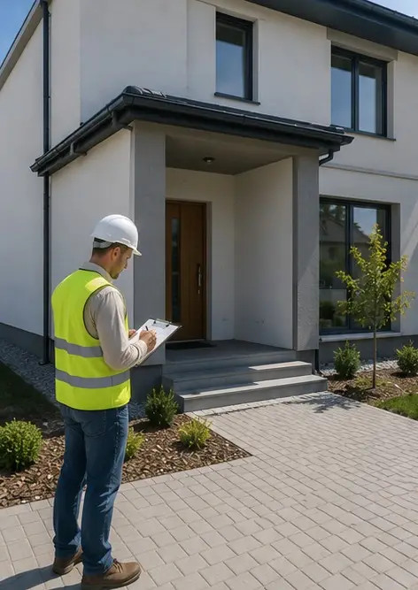
Photo #14 Exterior landscaping completed around the facility | 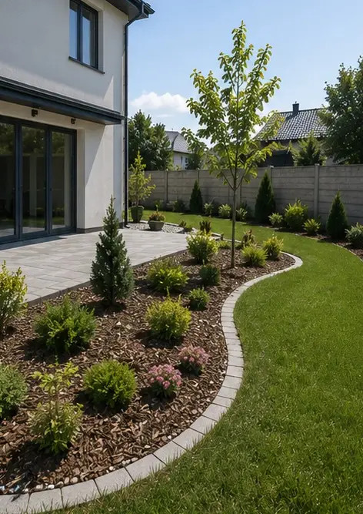
Photo #15 Completed building exterior after construction | 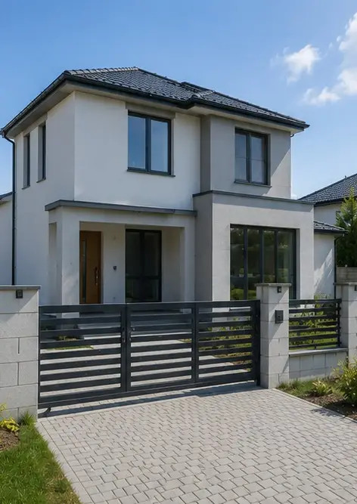
Photo #16 Completed building interior ready for operation | 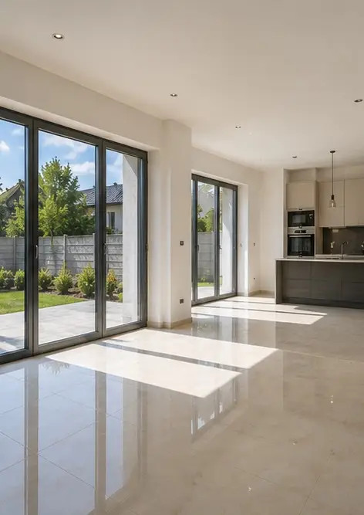

Create your own photo report online

Use Photo Reports to create structured PDF and Word photo reports with layouts, captions and export tools.

• Automatic page layouts
• PDF and DOCX export
• Photo captions and comments
• Before and after reports
• Inspection and maintenance reports
https://photo-reports.online

