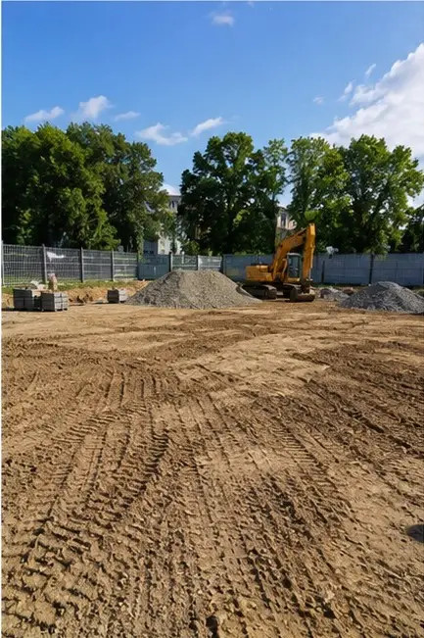 | 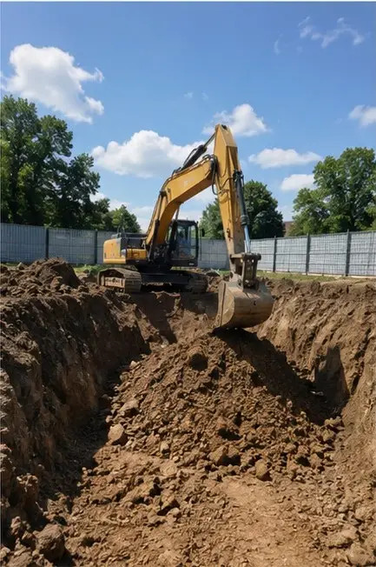
Photo #1 Site preparation work completed before the start of construction | Photo #2 Excavation work performed according to project requirements
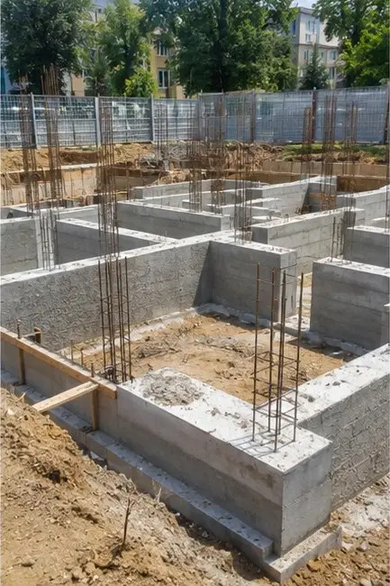 | 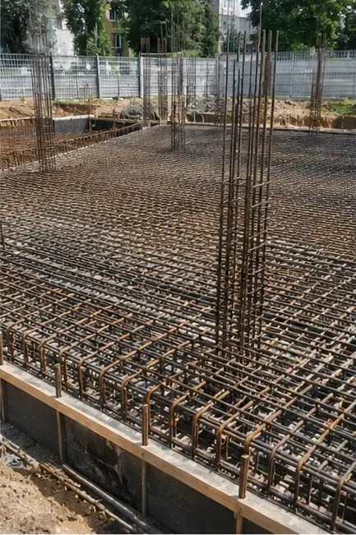
Photo #3 Foundation construction in progress | Photo #4 Reinforcement installation completed before concrete pouring
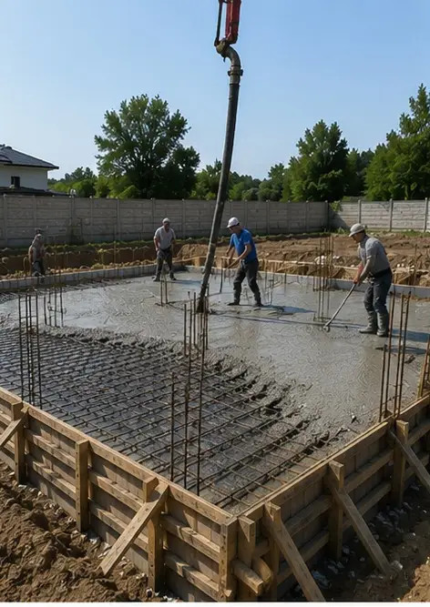 | 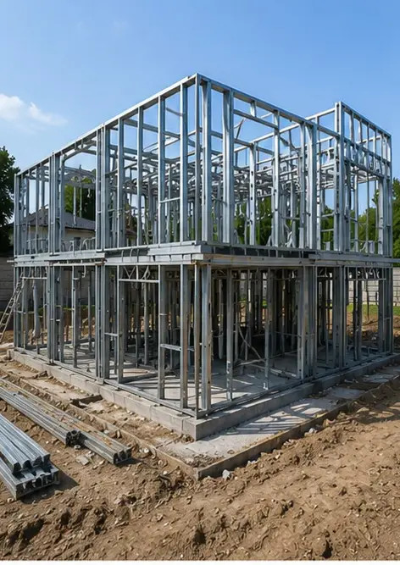
Photo #5 Concrete pouring operation performed on foundation elements | Photo #6 Structural frame assembly in progress
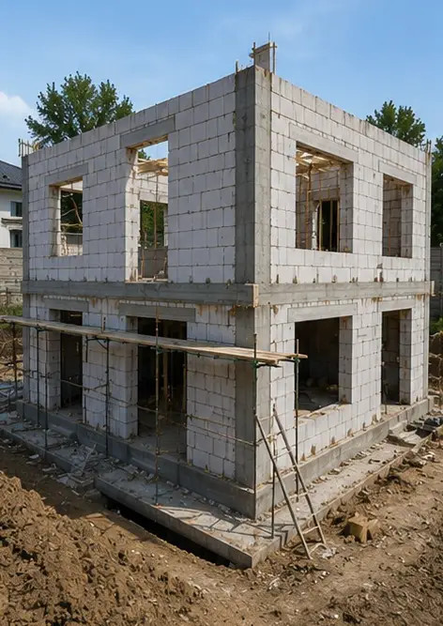 | 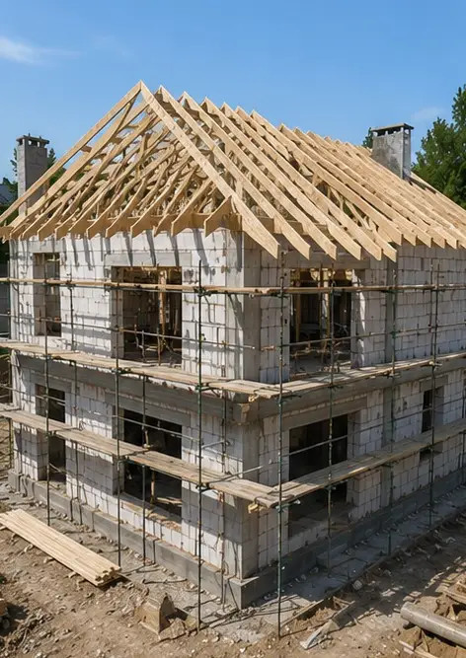
Photo #7 Exterior wall construction completed for the building section | Photo #8 Roof installation work completed
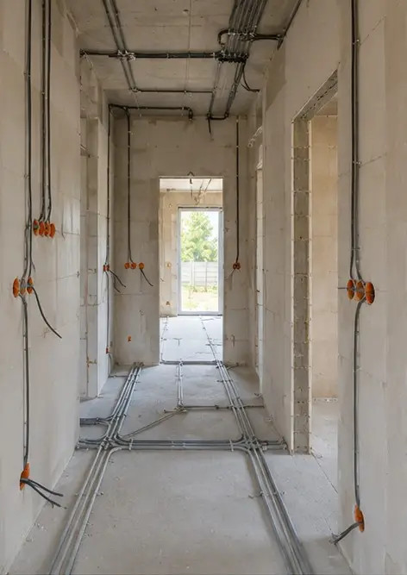 | 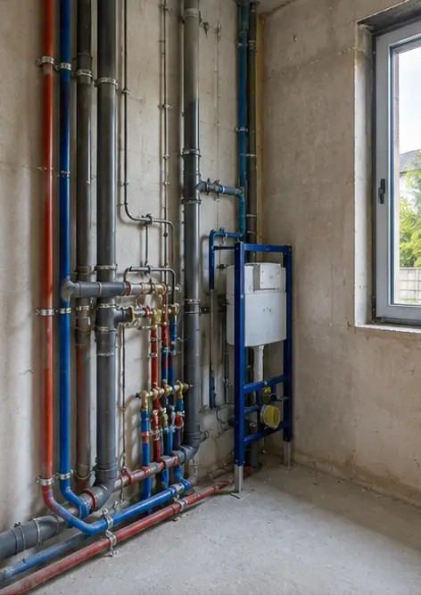
Photo #9 Electrical systems installation in progress | Photo #10 Plumbing systems installation completed in designated areas
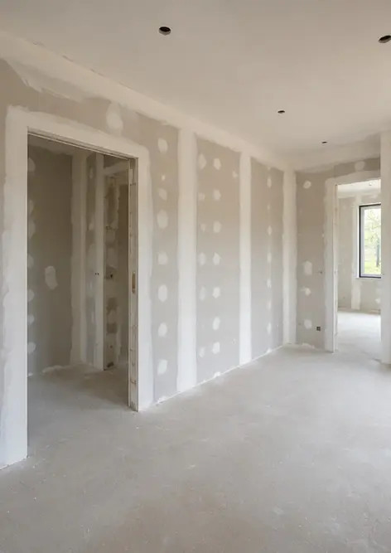 | 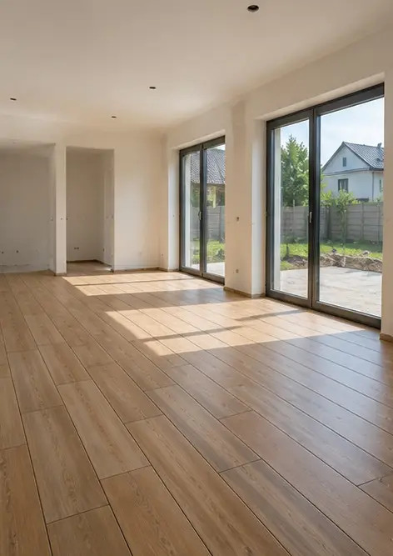
Photo #11 Interior wall finishing work in progress | Photo #12 Flooring installation completed according to project specifications
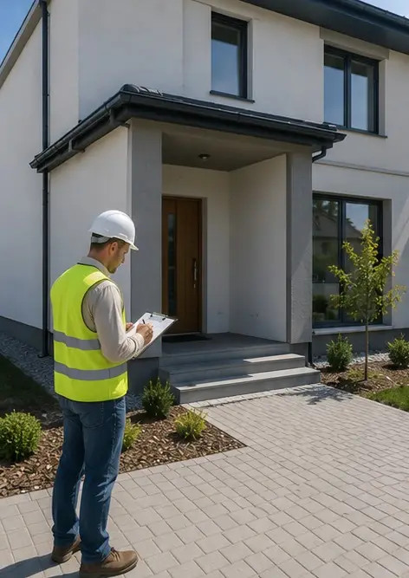 | 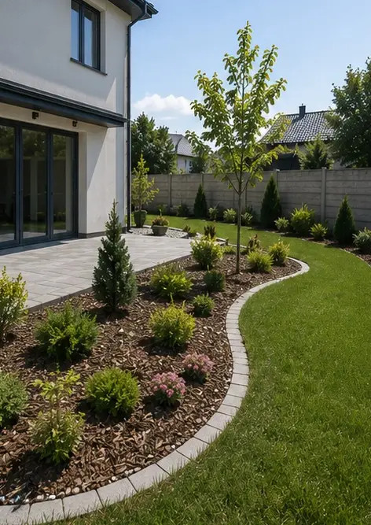
Photo #13 Final inspection of completed construction works | Photo #14 Exterior landscaping completed around the facility
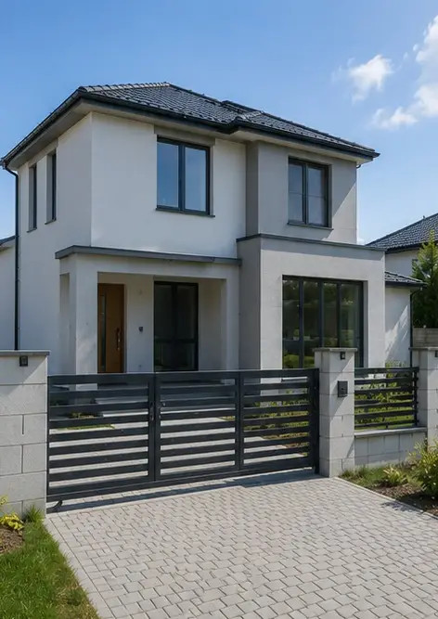 | 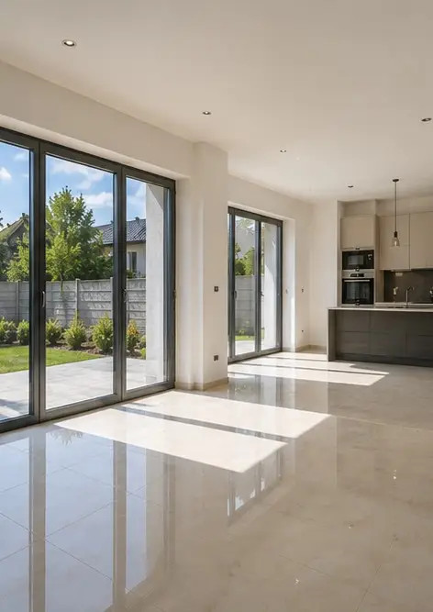
Photo #15 Completed building exterior after construction | Photo #16 Completed building interior ready for operation

Create your own photo report online

Use Photo Reports to create structured PDF and Word photo reports with layouts, captions and export tools.

• Automatic page layouts
• PDF and DOCX export
• Photo captions and comments
• Before and after reports
• Inspection and maintenance reports
https://photo-reports.online

